**VIRTUAL OFFICE**

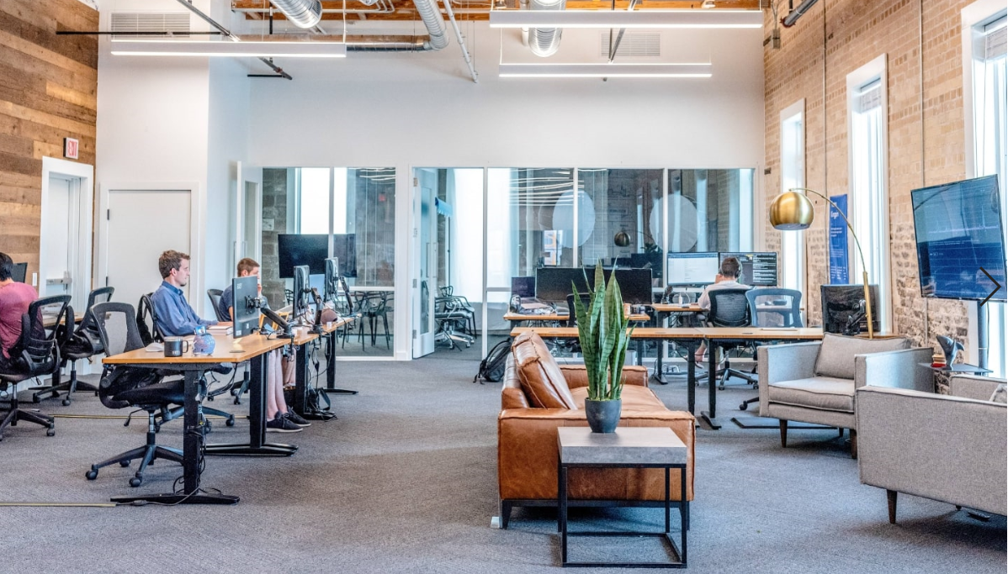

**A COMPUTER SCIENCE PROJECT REPORT**

Submitted by

**S. SELVA KARTHIK**

**N. ABINAV**

**SACHIN KUMAR**

**CLASS XI - B**

**BVM GLOBAL BOLLINENI HILLSIDE**

**SITHALAPAKKAM, CHENNAI- 600 126**

**TABLE OF CONTENTS**

|  |  |  |
| --- | --- | --- |
| **S.NO** | **TOPIC** | **PAGE NO.** |
| 1. | Overview of Python | 1 |
| 2. | Abstract | 3 |
| 3. | System Requirements | 4 |
| 4. | Dictionaries Used | 5 |
| 5. | Modules | 8 |
| 6. | Source Code | 9 |
| 7. | Output | 24 |
| 8. | Conclusion | 28 |
| 9. | Shortcomings and Future Enhancements | 29 |
| 10. | Bibliography/Webliography | 30 |

**OVERVIEW OF PYTHON**

Python is a high-level, interpreted, interactive and object-oriented scripting language. Python is designed to be highly readable. It uses English keywords frequently whereas the other languages use punctuations. It has fewer syntactical constructions than other languages.

* **Python is Interpreted** − Python is processed at runtime by the interpreter. You do not need to compile your program before executing it. This is similar to PERL and PHP.
* **Python is Interactive** − You can actually sit at a Python prompt and interact with the interpreter directly to write your programs.
* **Python is Object-Oriented** − Python supports Object-Oriented style or technique of programming that encapsulates code within objects.
* **Python is a Beginner's Language** − Python is a great language for the beginner-level programmers and supports the development of a wide range of applications from simple text processing to WWW browsers to games.

**History of Python**

Python was developed by Guido van Rossum in the late eighties and early nineties at the National Research Institute for Mathematics and Computer Science in the Netherlands.

* Python is derived from many other languages, including ABC, Modula-3, C, C++, Algol-68, SmallTalk, and Unix shell and other scripting languages.
* Python is copyrighted. Like Perl, Python source code is now available under the GNU General Public License (GPL).
* Python is now maintained by a core development team at the institute, although Guido van Rossum still holds a vital role in directing its progress.
* Python 1.0 was released in November 1994. In 2000, Python 2.0 was released. Python 2.7.11 is the latest edition of Python 2.
* Meanwhile, Python 3.0 was released in 2008. Python 3 is not backward compatible with Python 2. The emphasis in Python 3 had been on the removal of duplicate programming constructs and modules so that "There should be one -- and preferably only one -- obvious way to do it." Python 3.5.1 is the latest version of Python 3.

**Python Features**

Python's features include −

* **Easy-to-learn** − Python has few keywords, simple structure, and a clearly defined syntax. This allows a student to pick up the language quickly.
* **Easy-to-read** − Python code is more clearly defined and visible to the eyes.
* **Easy-to-maintain** − Python's source code is fairly easy-to-maintain.
* **A broad standard library** − Python's bulk of the library is very portable and cross-platform compatible on UNIX, Windows, and Macintosh.
* **Interactive Mode** − Python has support for an interactive mode which allows interactive testing and debugging of snippets of code.
* **Portable** − Python can run on a wide variety of hardware platforms and has the same interface on all platforms.
* **Extendable** − You can add low-level modules to the Python interpreter. These modules enable programmers to add to or customize their tools to be more efficient.
* **Databases** − Python provides interfaces to all major commercial databases.
* **GUI Programming** − Python supports GUI applications that can be created and ported to many system calls, libraries and windows systems, such as Windows MFC, Macintosh, and the X Window system of Unix.
* **Scalable** − Python provides a better structure and support for large programs than shell scripting.

Apart from the above-mentioned features, Python has a big list of good features. A, few are listed below −

* It supports functional and structured programming methods as well as OOP.
* It can be used as a scripting language or can be compiled to byte-code for building large applications.
* It provides very high-level dynamic data types and supports dynamic type checking.

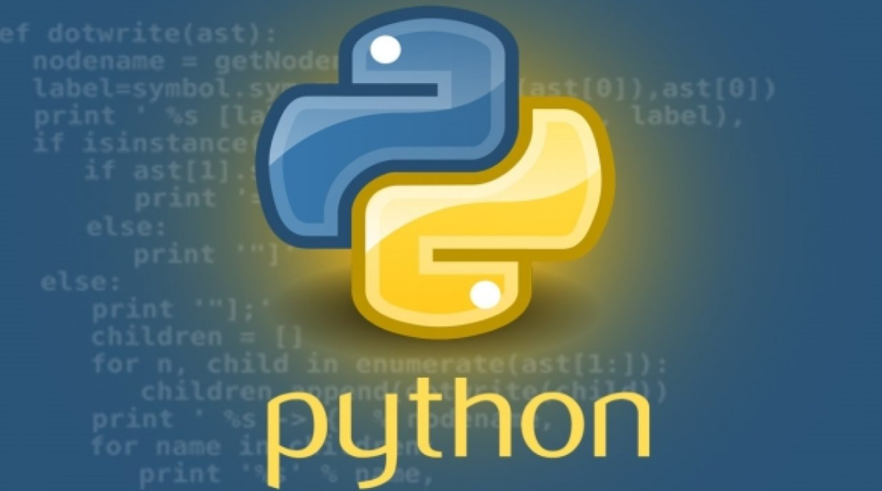

**ABSTRACT**

* This Software Brings You a Feeling of Working and Going Inside a Real Office and Can be Used as a Alternative for all those IT Workers who are Working inside their House due to Covid-19 .
* It has Different Sections and Roles like Employee, Project Manager, Interviewer, Client and the Boss of the Office.
* Each and Every Section is Given A Specific Role And Specific Function and many more Interesting and Real Life Applications Things.
* This Software Also gives You a Knowledge of the Things Happening Inside The Big Offices and the Power of Each and Every Role.



**SYSTEM REQUIREMENTS**

### Windows:

* Microsoft Windows 10/8/7/Vista/2003/XP (incl.64-bit)
* RAM:1 GB minimum / 2 GB recommended
* Minimum Screen Resolution: 1024x768
* Python 3.5 or higher, Jython, PyPy or IronPython

### Mac:

* Mac OS X 10.8 or higher
* 1 GB RAM minimum / 2 GB RAM recommended
* Python 3.5 or higher, Jython, PyPy or IronPython

### Linux:

* 512 MB RAM minimum, 1 GB RAM recommended
* 1024x768 minimum screen resolution
* Python 3.5 or higher, Jython, PyPy or IronPython

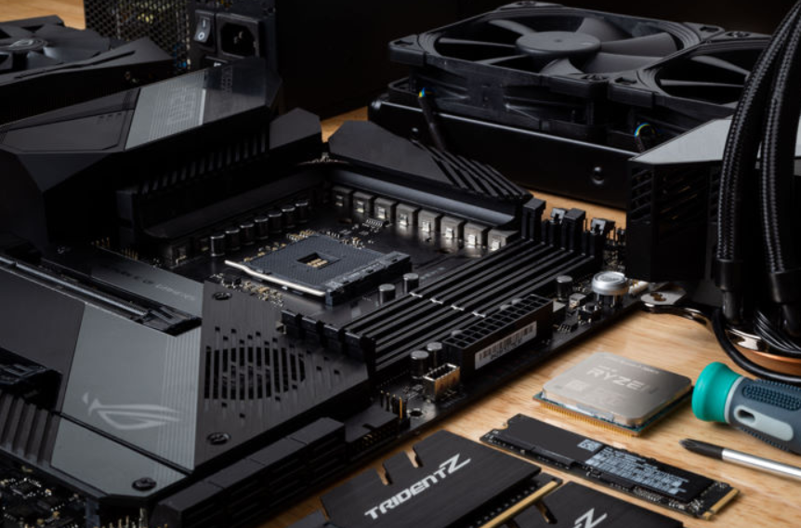

**DICTIONARIES USED**

* **Office**

**Includes All Workers Inside the Office**

**Key : (Office ID , Password)**

**Value : [Name, Years of Experience, Salary, Status]**

* **Off_Emp**

**Includes All Employees Working in the Office**

**Key : (Office ID, Password)**

**Value : [Name, Years of Experience, Salary, Status]**

* **Off_Pm**

**Includes All Project Managers Working in the Office**

**Key : (Office ID, Password)**

**Value : [Name, Years of Experience, Salary, Status, Successful Projects]**

* **Off_Client**

**Includes All Clients Working in the Office**

**Key : (Office ID, Password)**

**Value : :[Name, Years of Experience, Salary, Status]**

* **Off_Interviewer**

**Includes All Interviewers Working in the Office**

**Key : (Office ID, Password)**

**Value : [Name, Years of Experience, Salary, Status]**

* **Interview**

**Includes All Candidates Who sent the Application Form**

**Key : Length of The Dictionary + 1**

**Value : [Name, Address, Designation, Phone Number,**

**Resume, Years Of Experience, Date Of**

**Birth]**

* **New_Project**

**Includes All New Projects Created by the Client**

**Key : Length of the Dictionary + 1**

**Value : [Name of the Project, No. Employees**

**Required, Estimated Time]**

* **Look_Prg**

**Includes All Employees Who are Looking for a Project**

**Key : Office ID of the Employee**

**Value : [Name, Years of Experience]**

* **Query**

**Includes All Queries Submitted by the Workers in the Office**

**Key : (Office ID, Password)**

**Value : [Name, Queries]**

* **Project**

**Includes All Projects Been Handled By Each and Every Project Manager**

**Key : Project Name**

**Value : [Name, Team Members, Estimated Time]**

* **Submit_Prg**

**Includes All Projects that are Submitted by the Project Managers to the Clients**

**Key : Project Name**

**Value : [Name, Team Members, Estimated Time]**

* **Resig**

**Includes All Resignation Letters Sent to the Boss by the Workers**

**Key : (Office ID, Password)**

**Value : [Name, Reason for Resignation]**

* **Food**

**Includes All the Food Items In the Food Canteen**

**Key : Item Name**

**Value : (Flavour , Price)**

**MODULES**

* Sound Module
* Random Module

**SOURCE CODE**

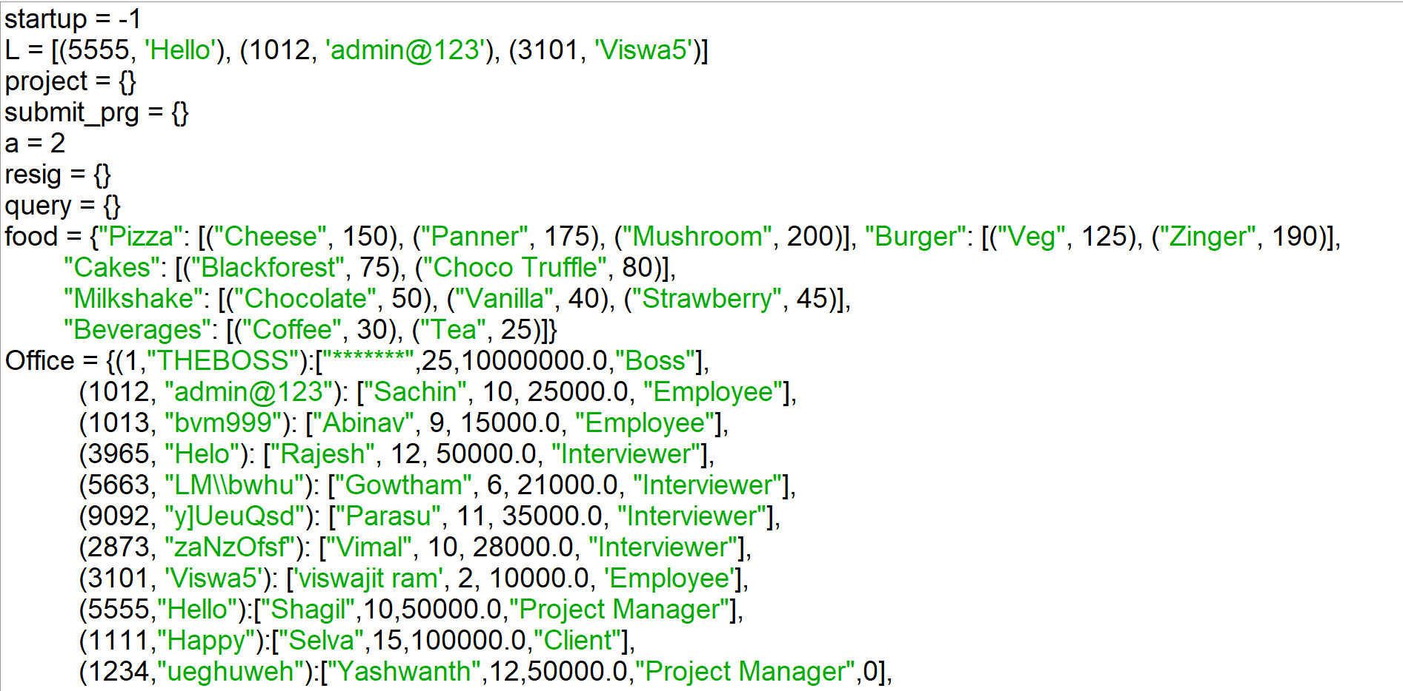

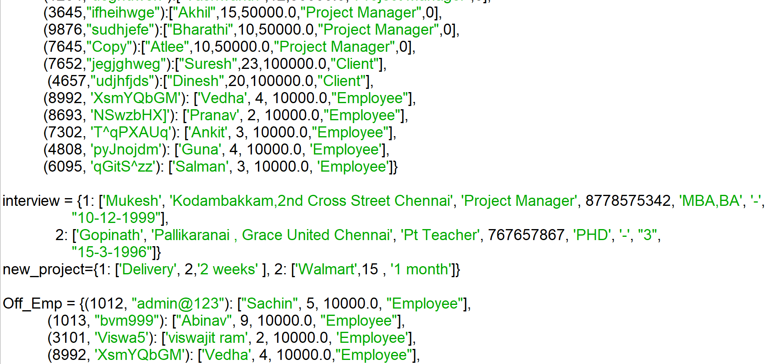

**SOURCE CODE**

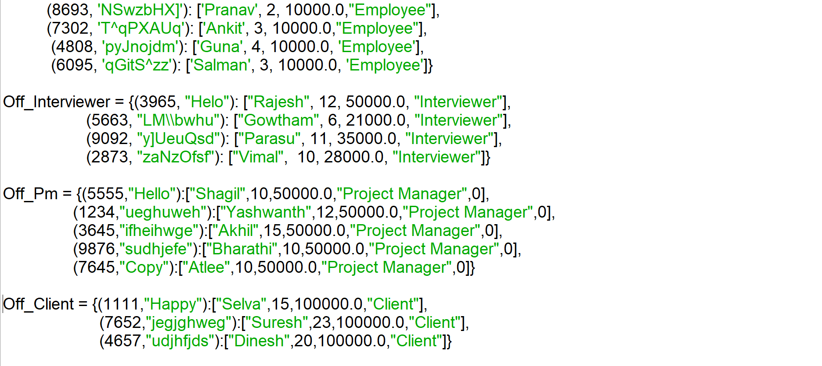

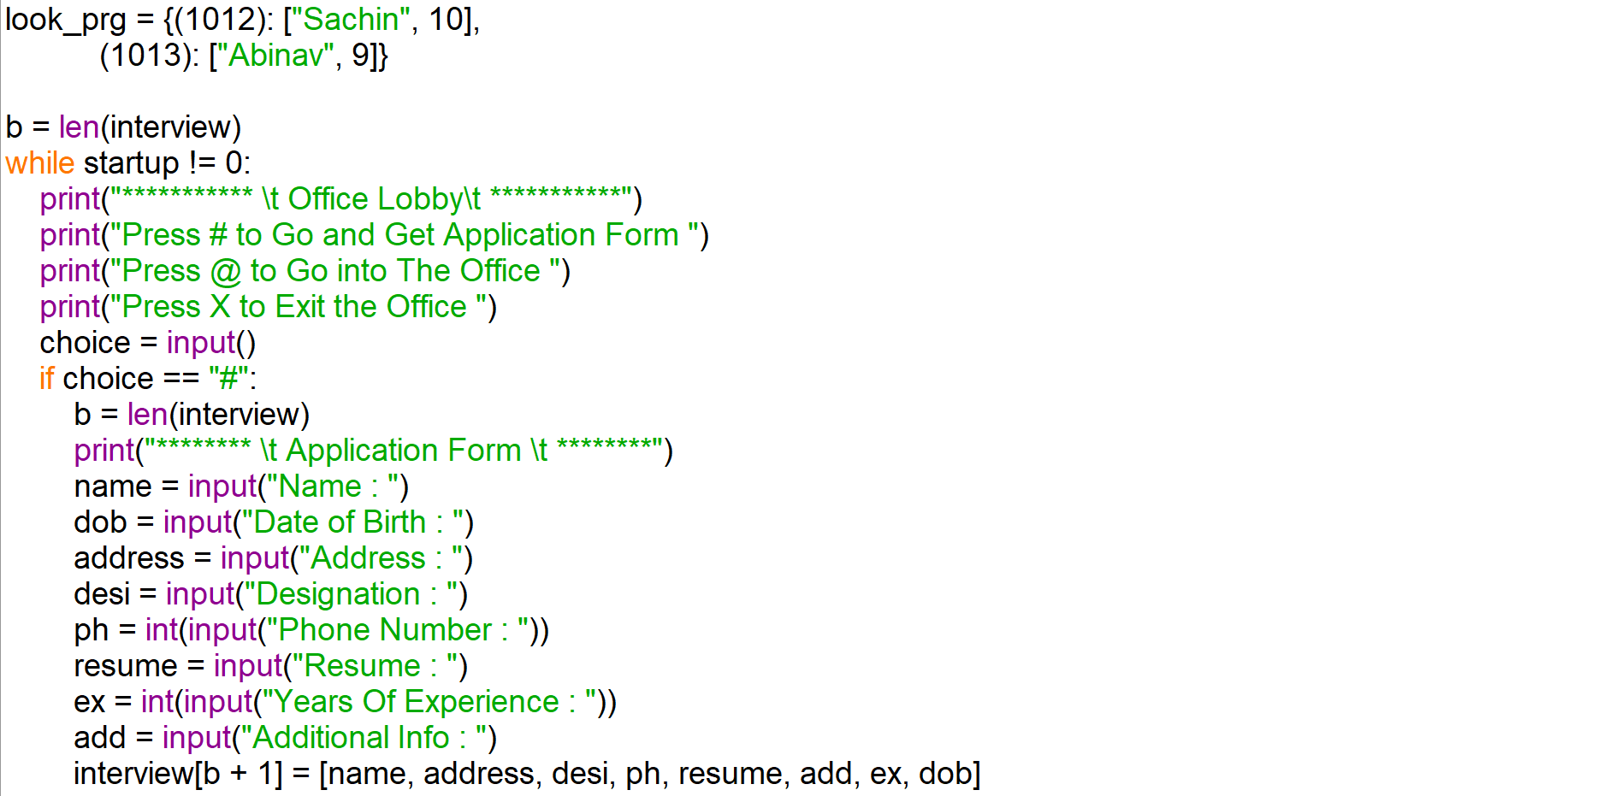

**SOURCE CODE**

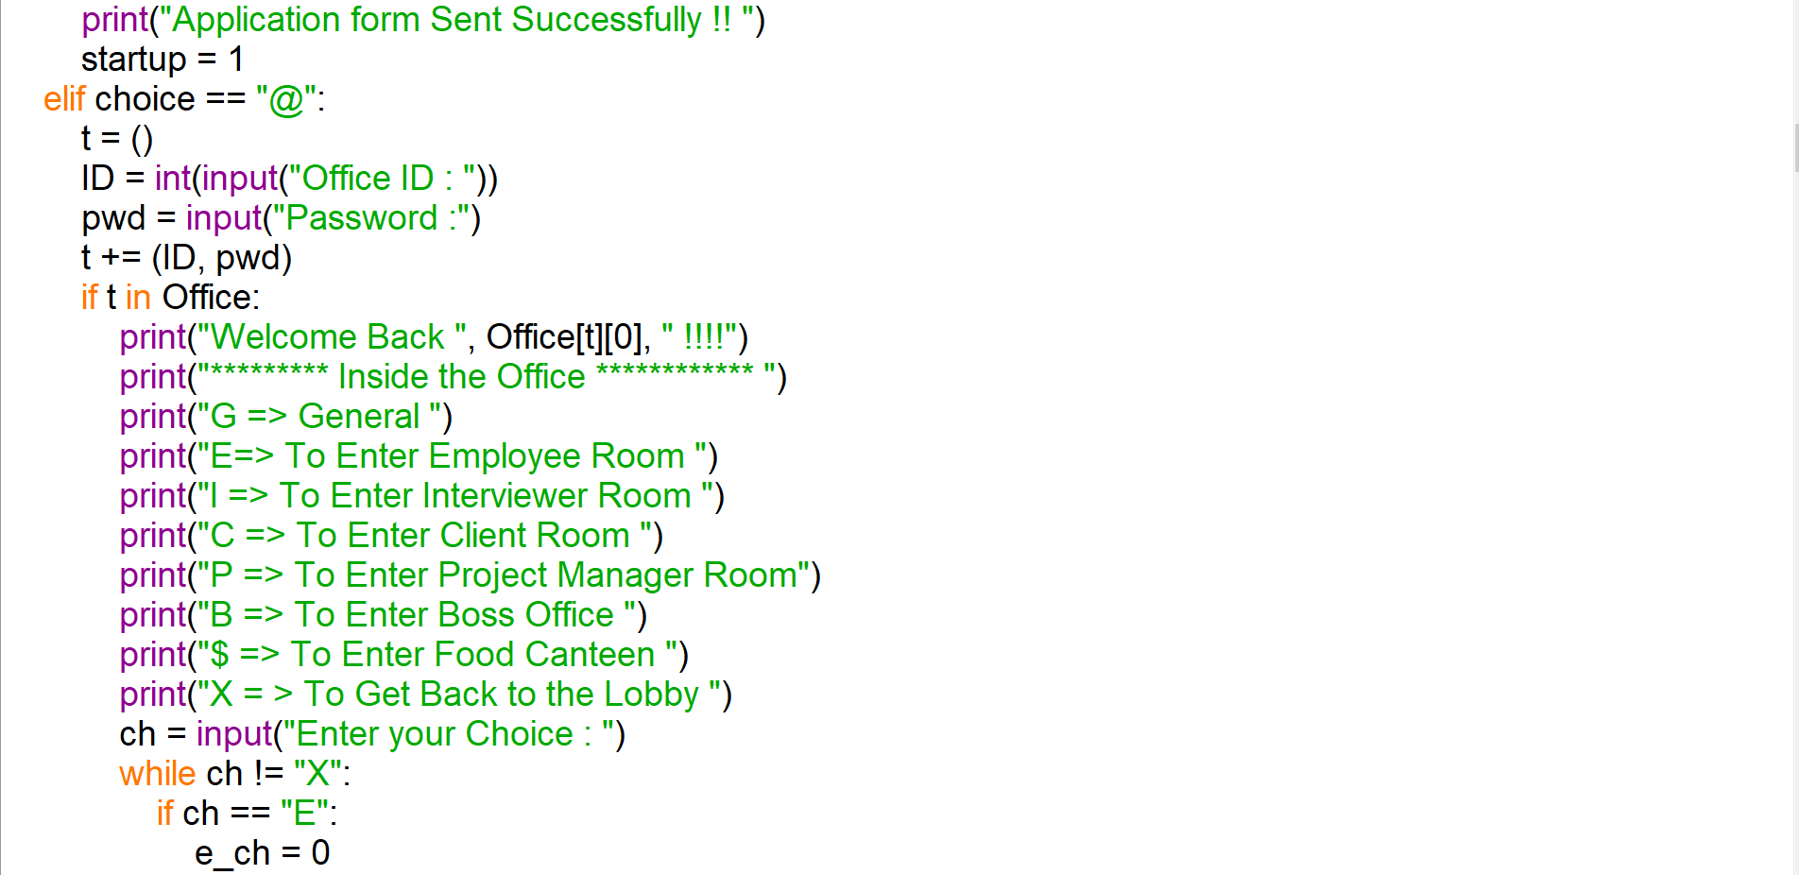

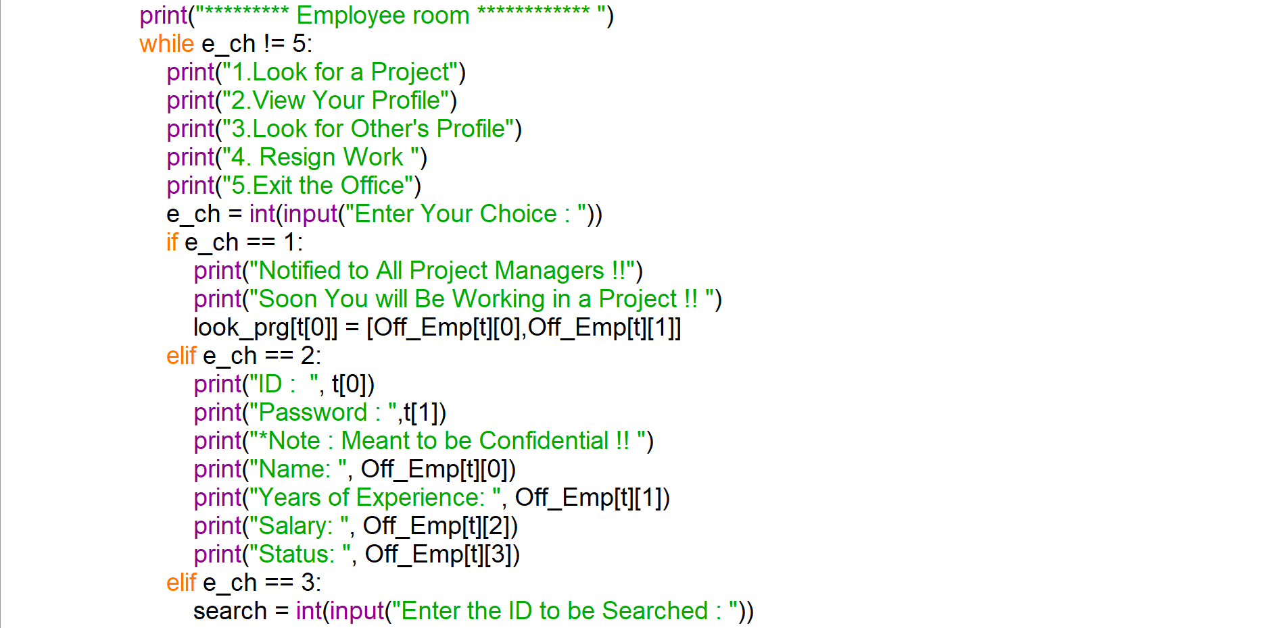

**SOURCE CODE**

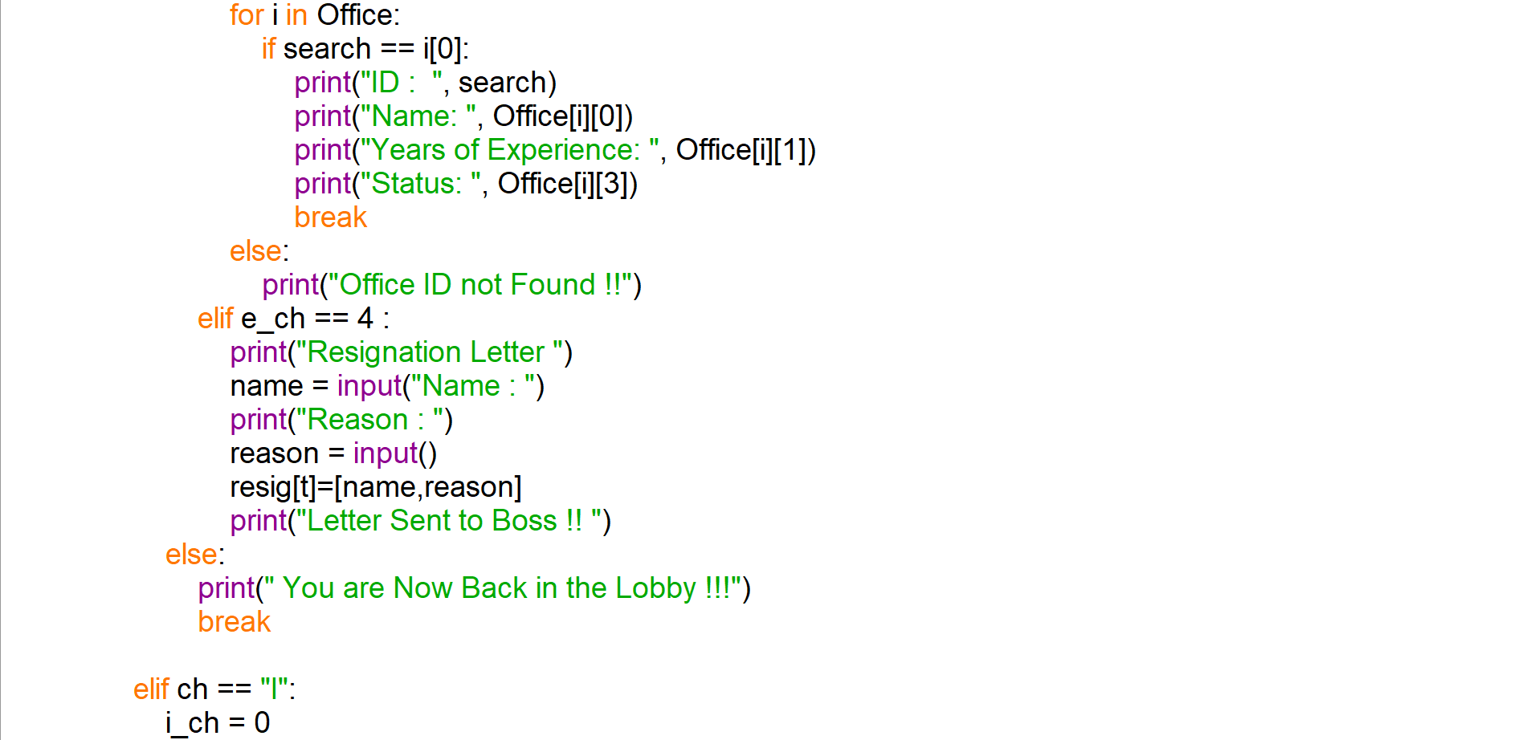

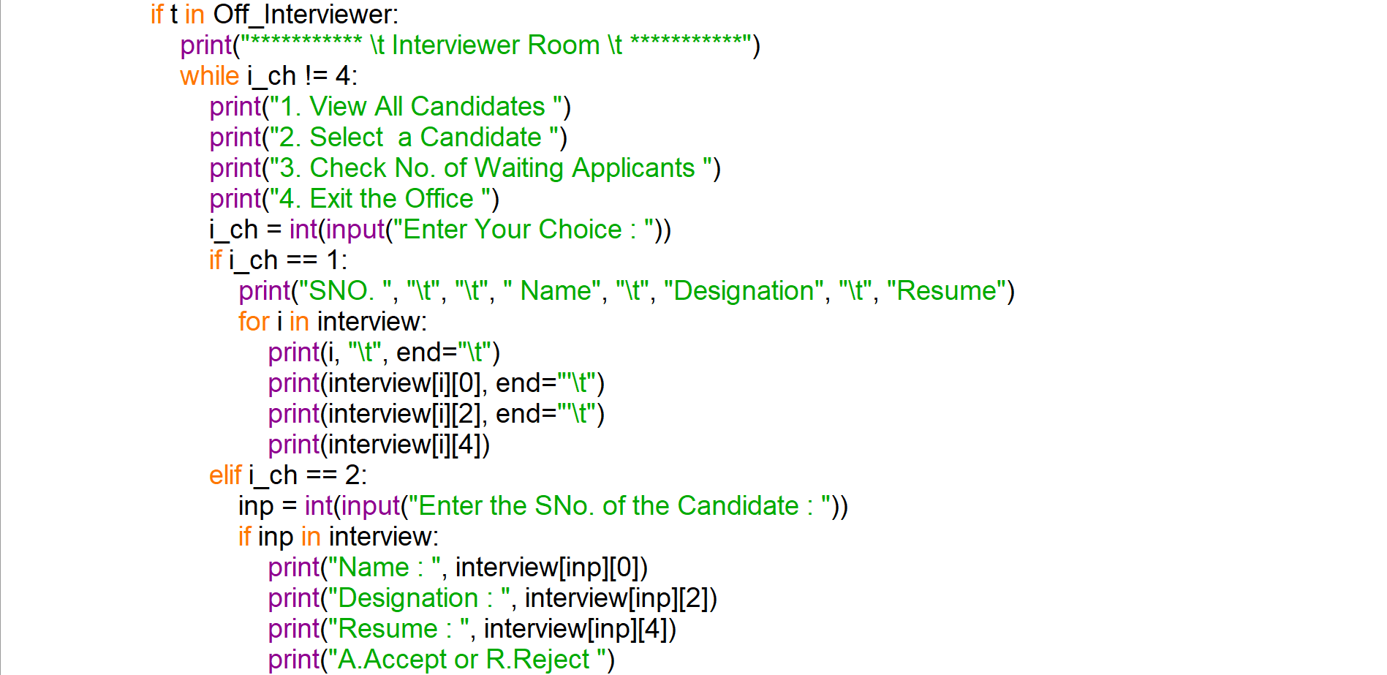

**SOURCE CODE**

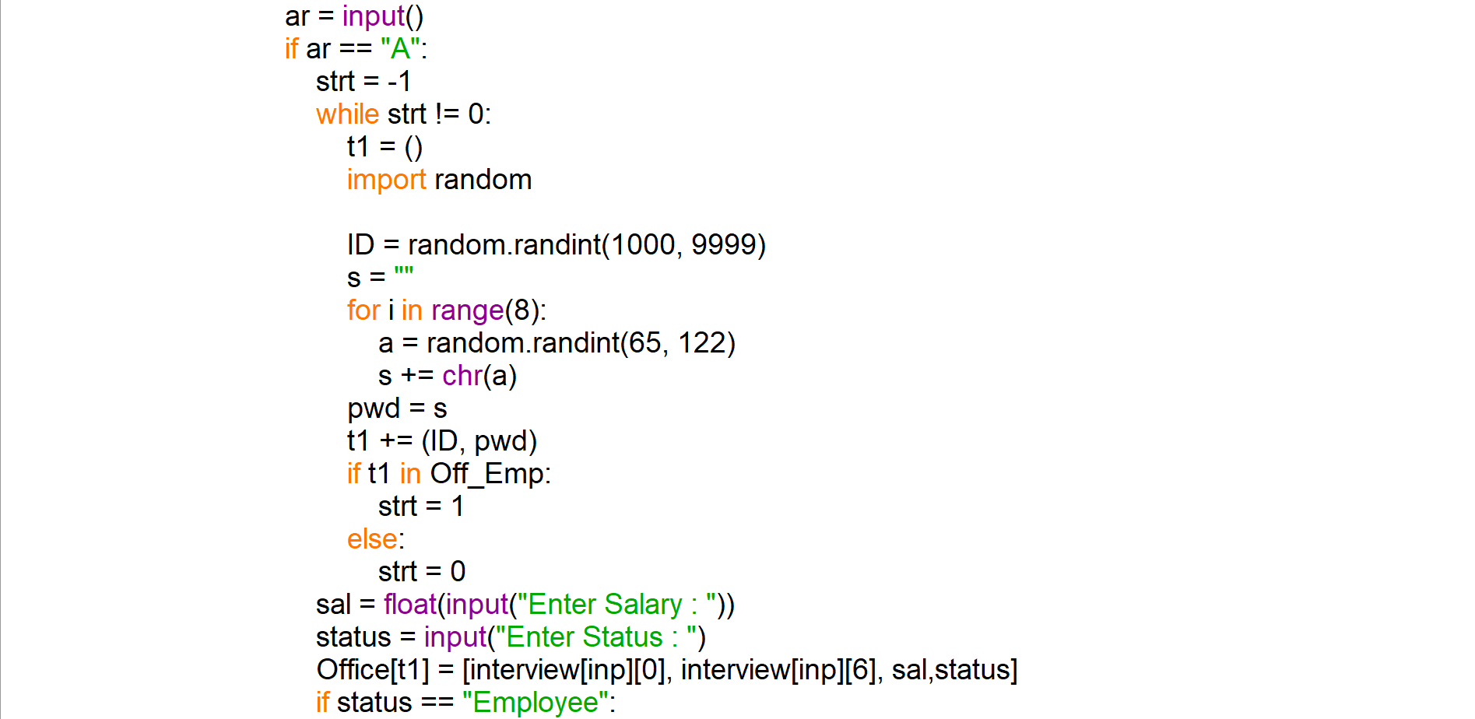

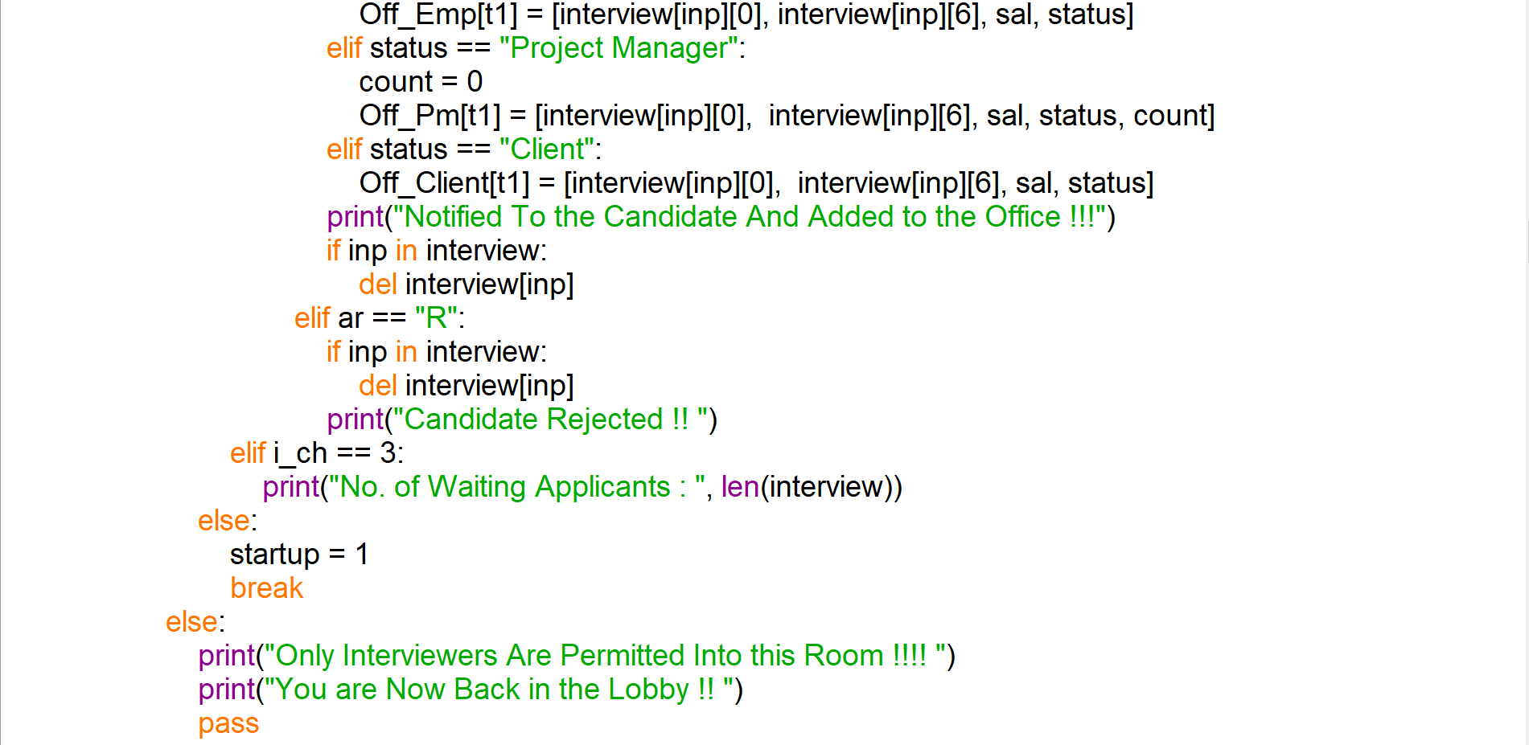

**SOURCE CODE**

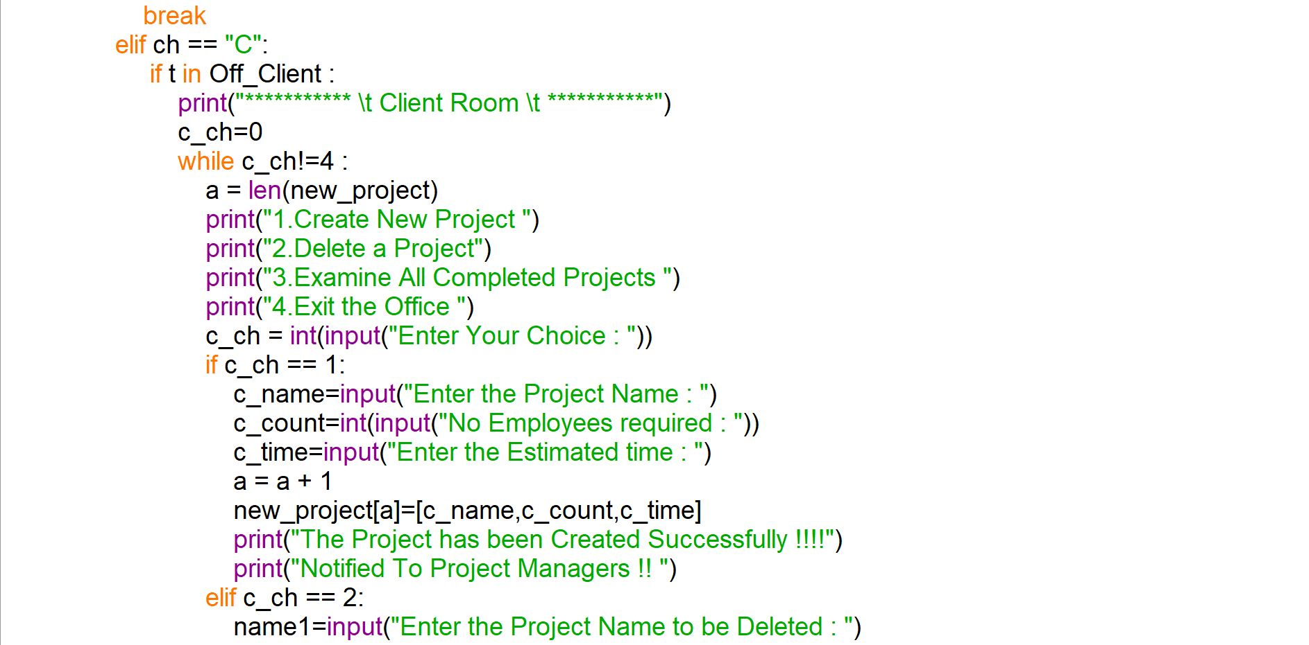

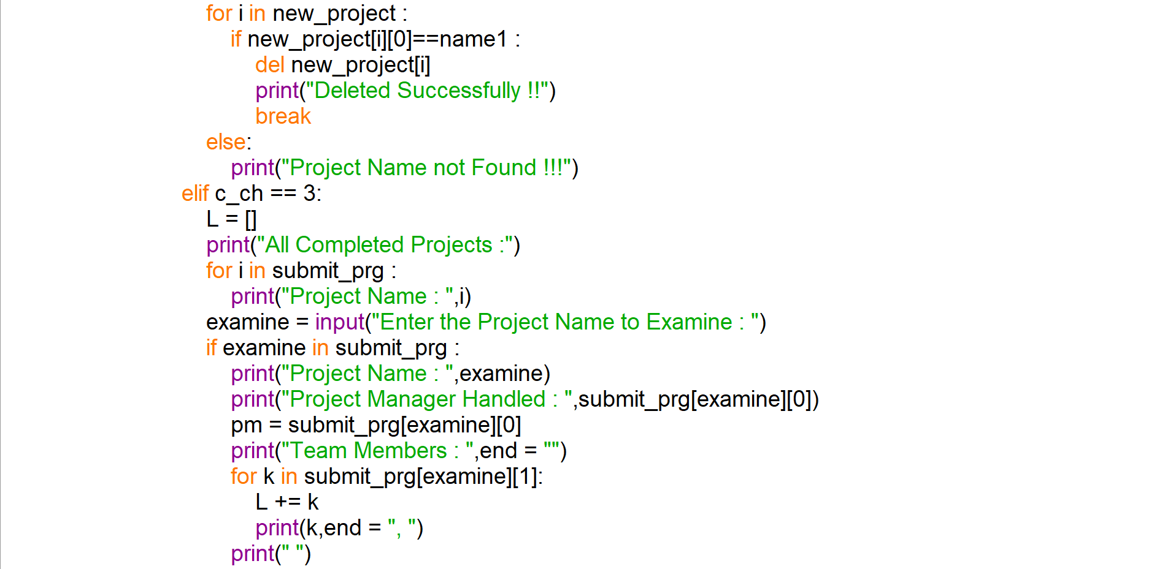

**SOURCE CODE**

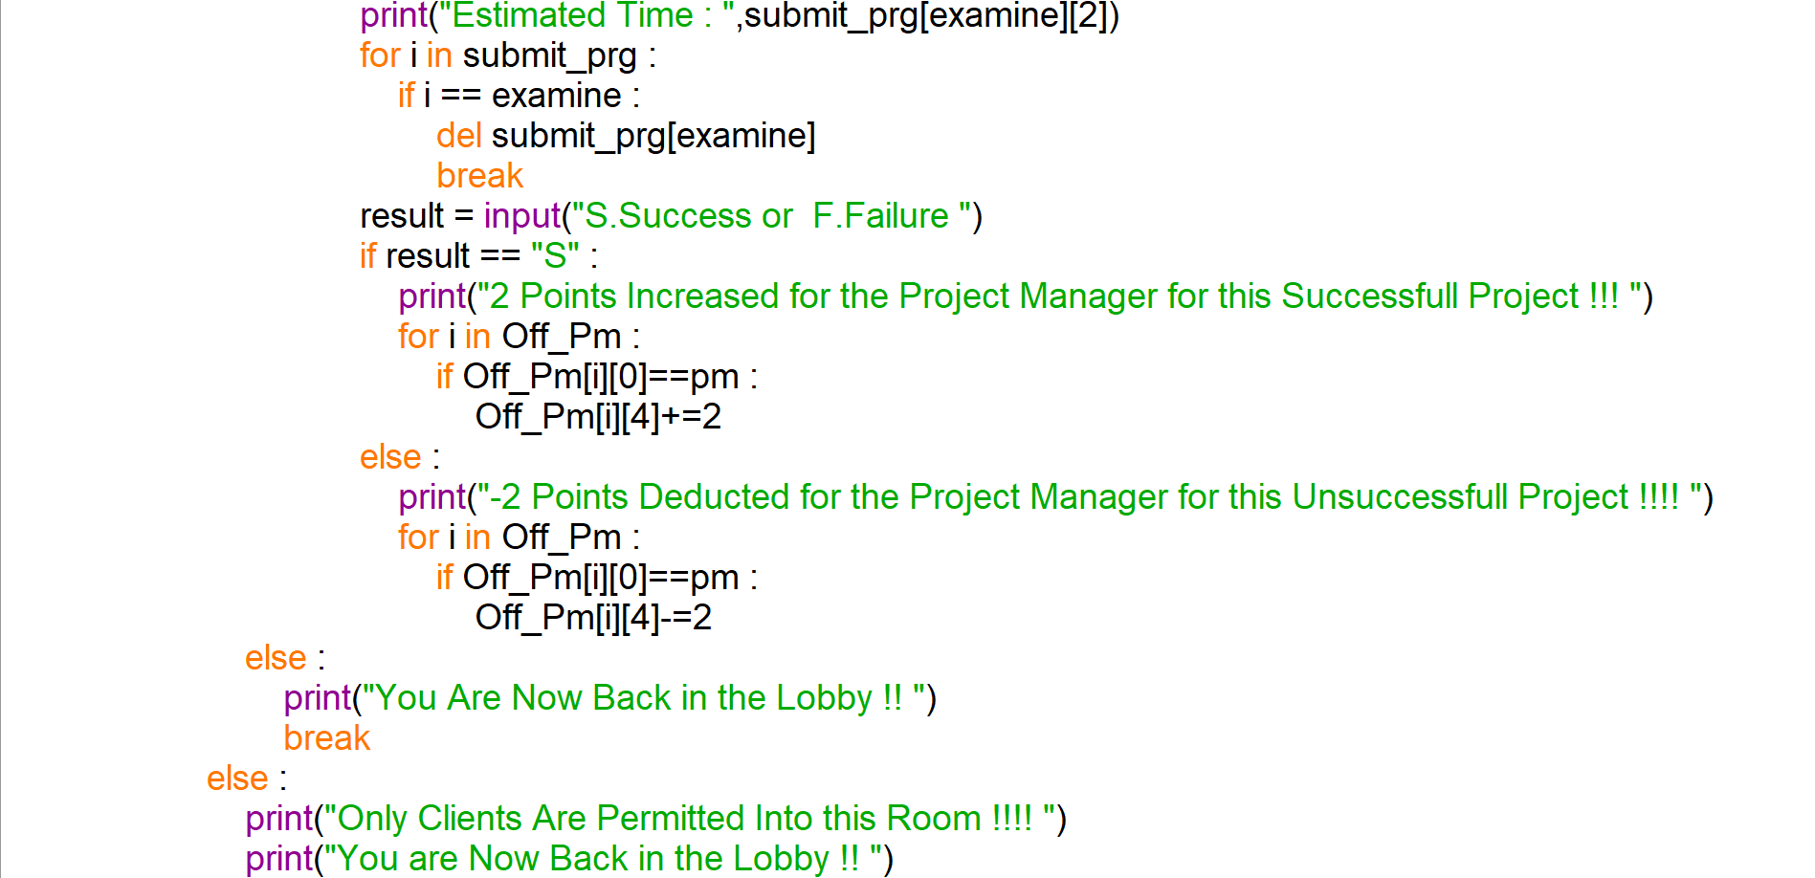

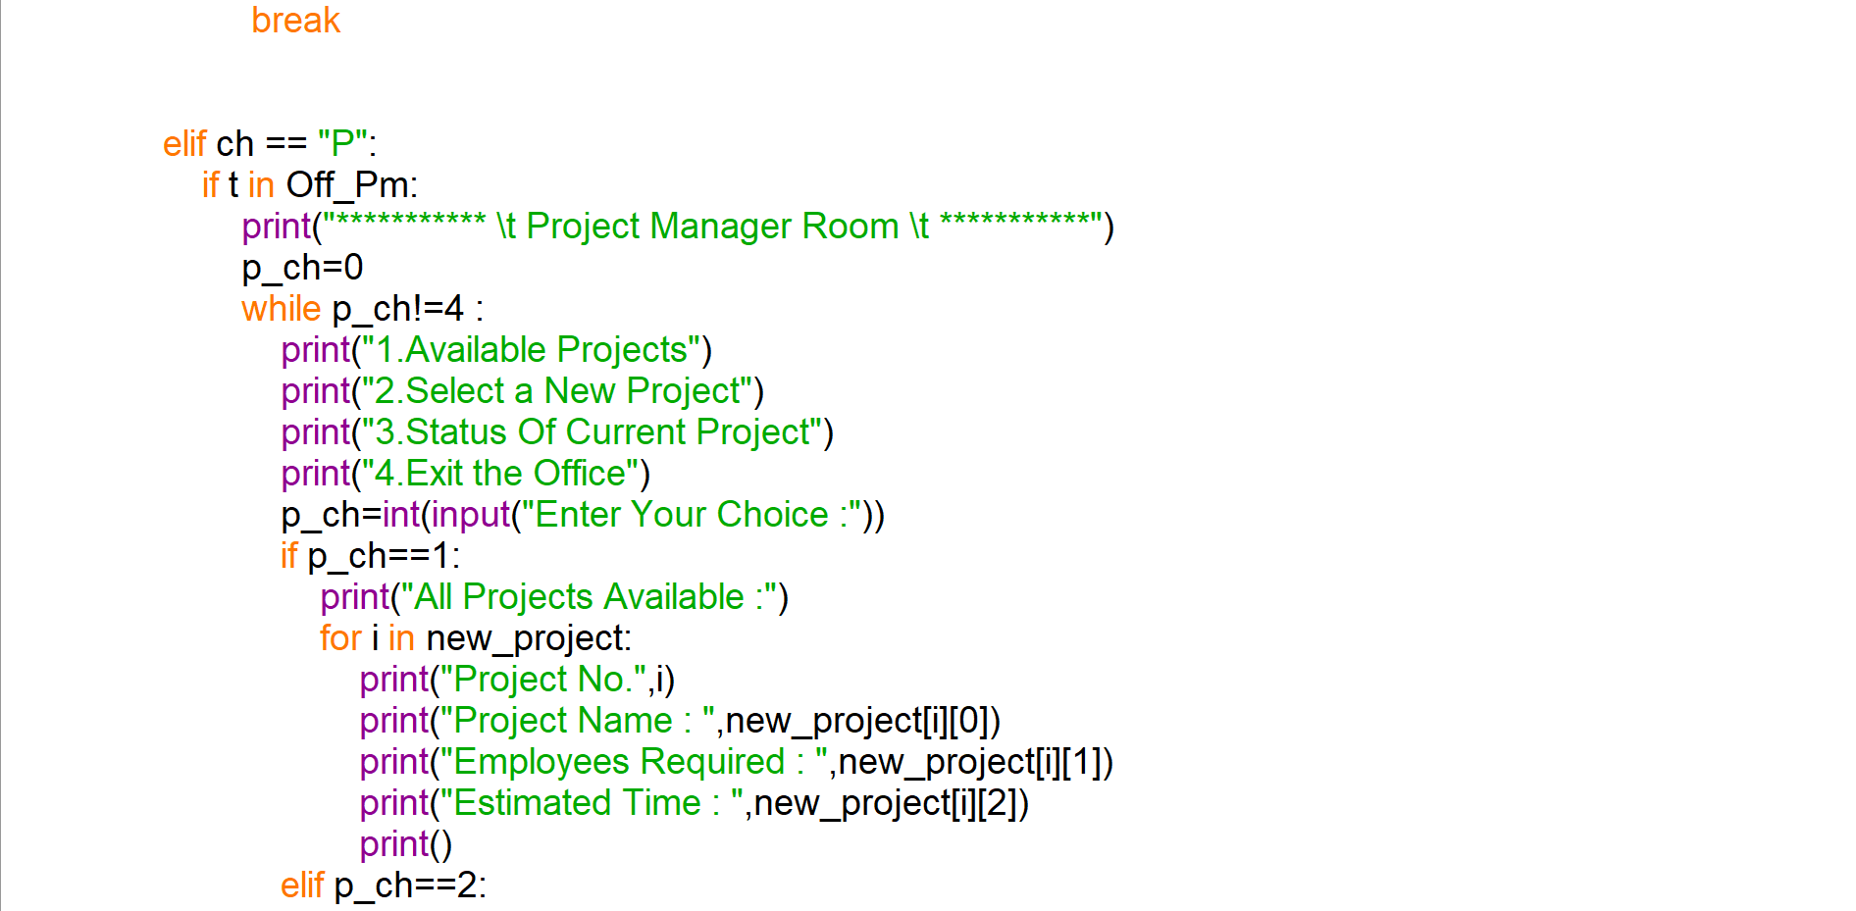

**SOURCE CODE**

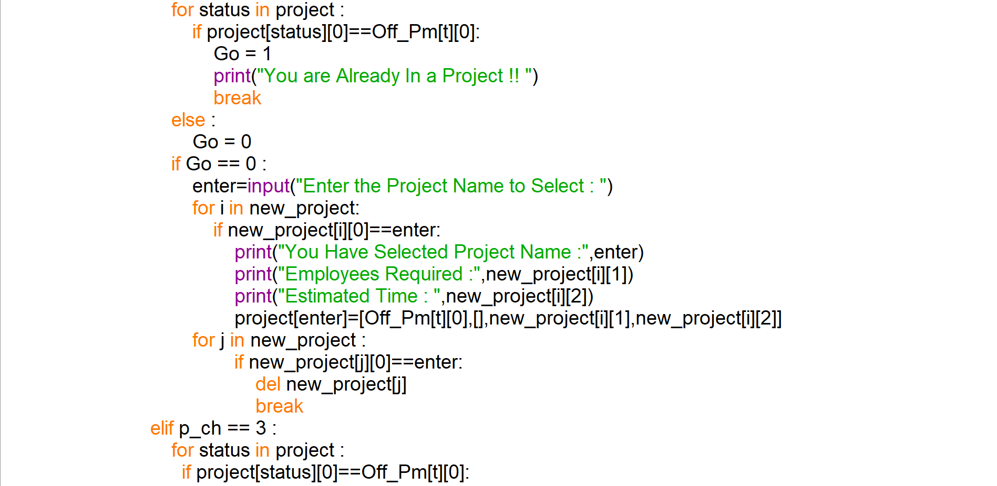

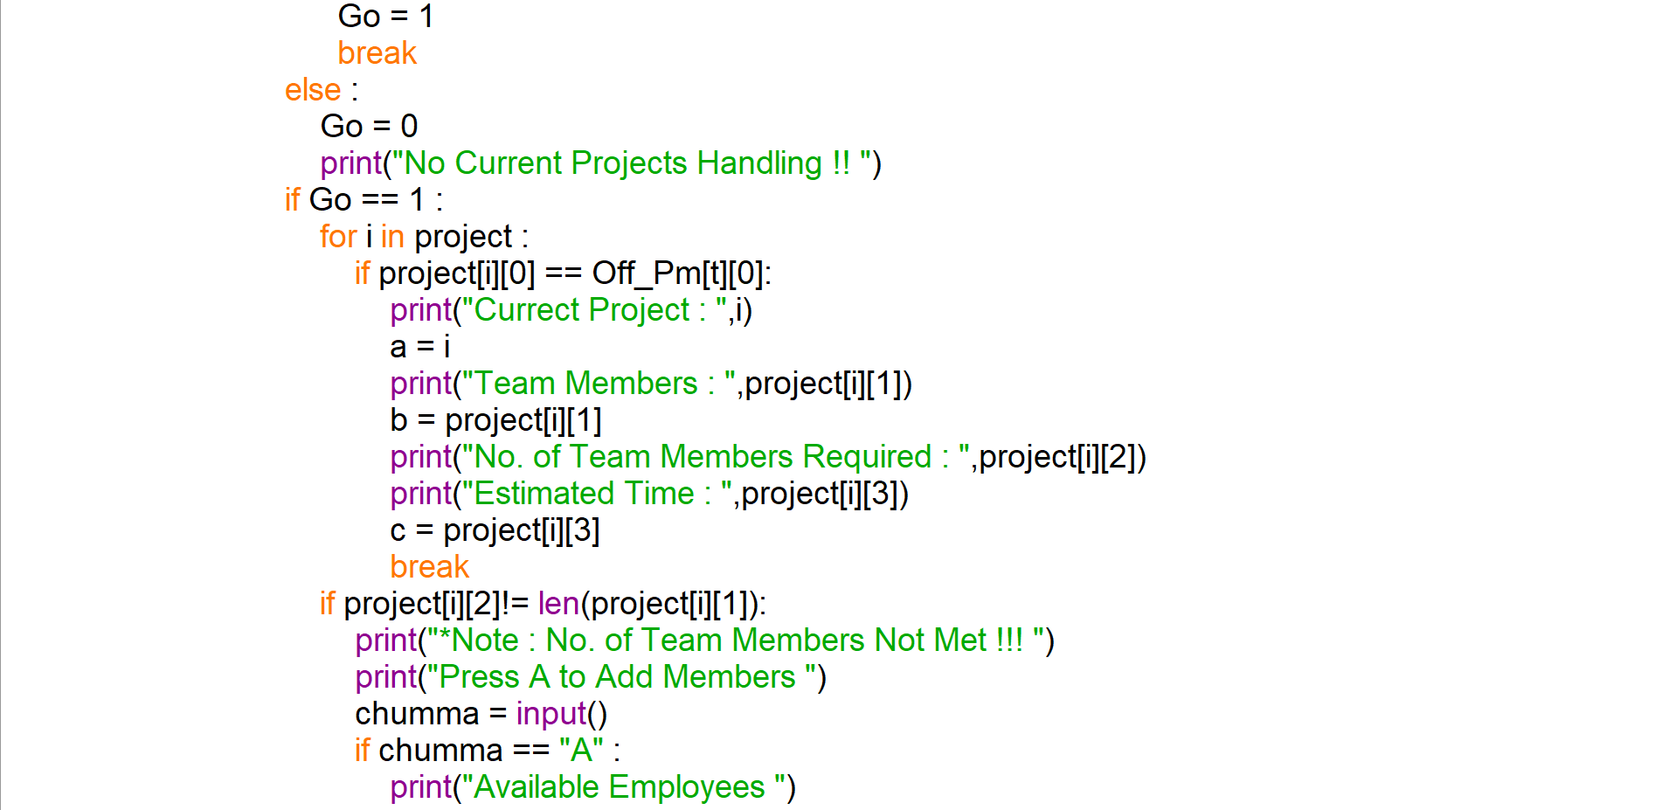

**SOURCE CODE**

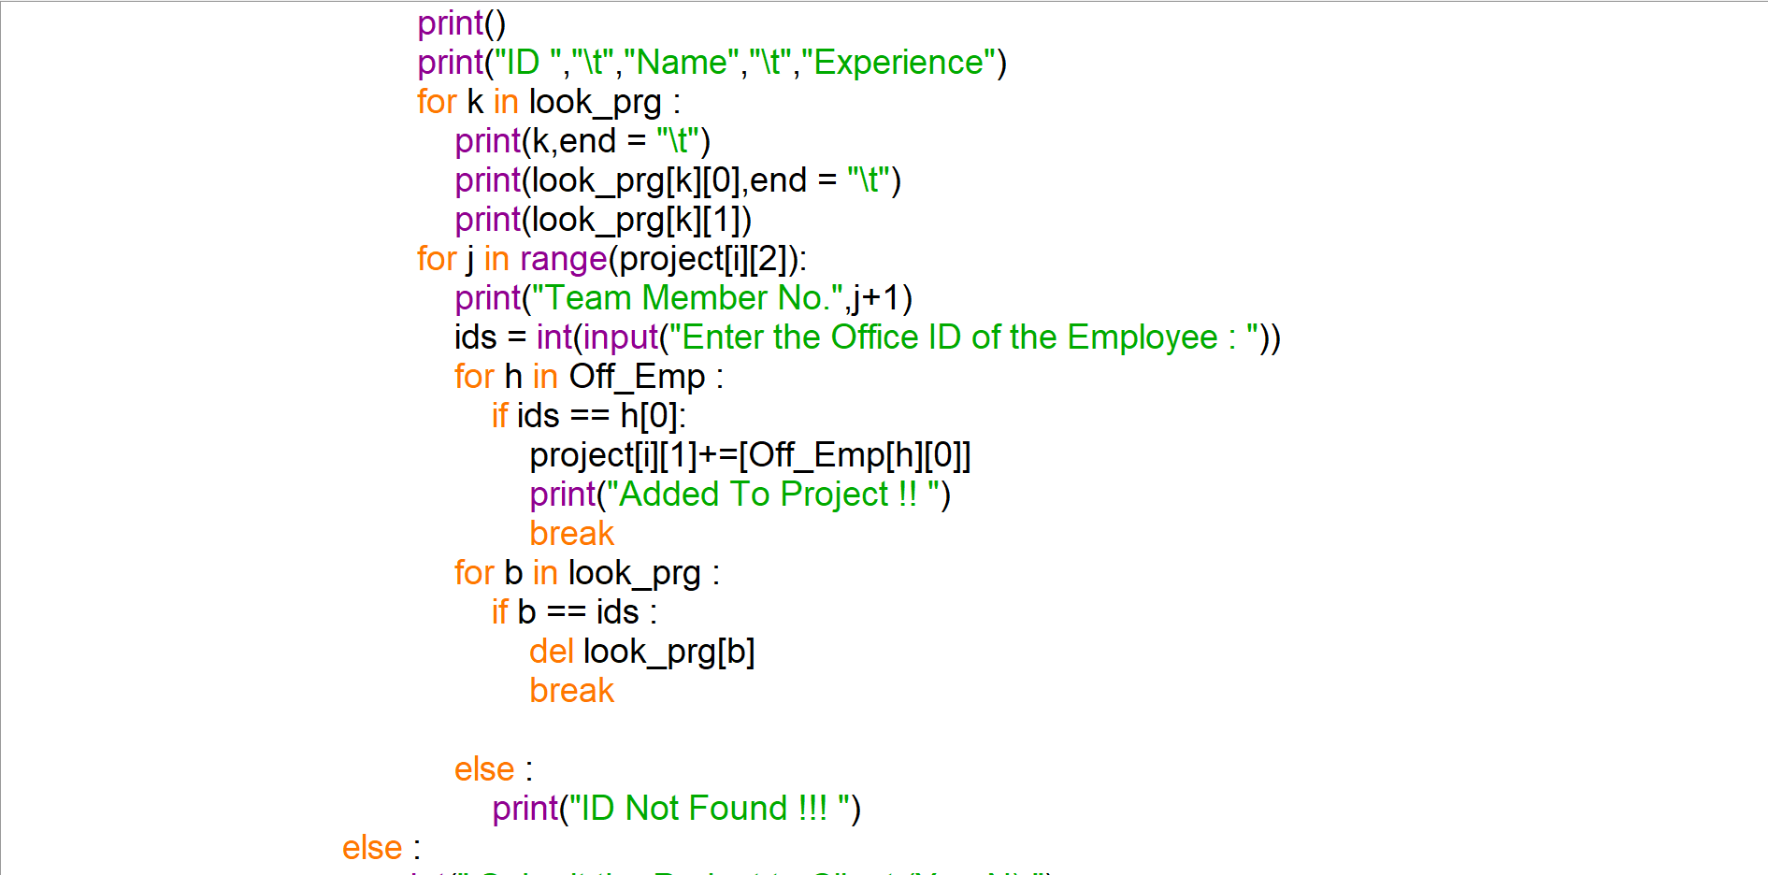

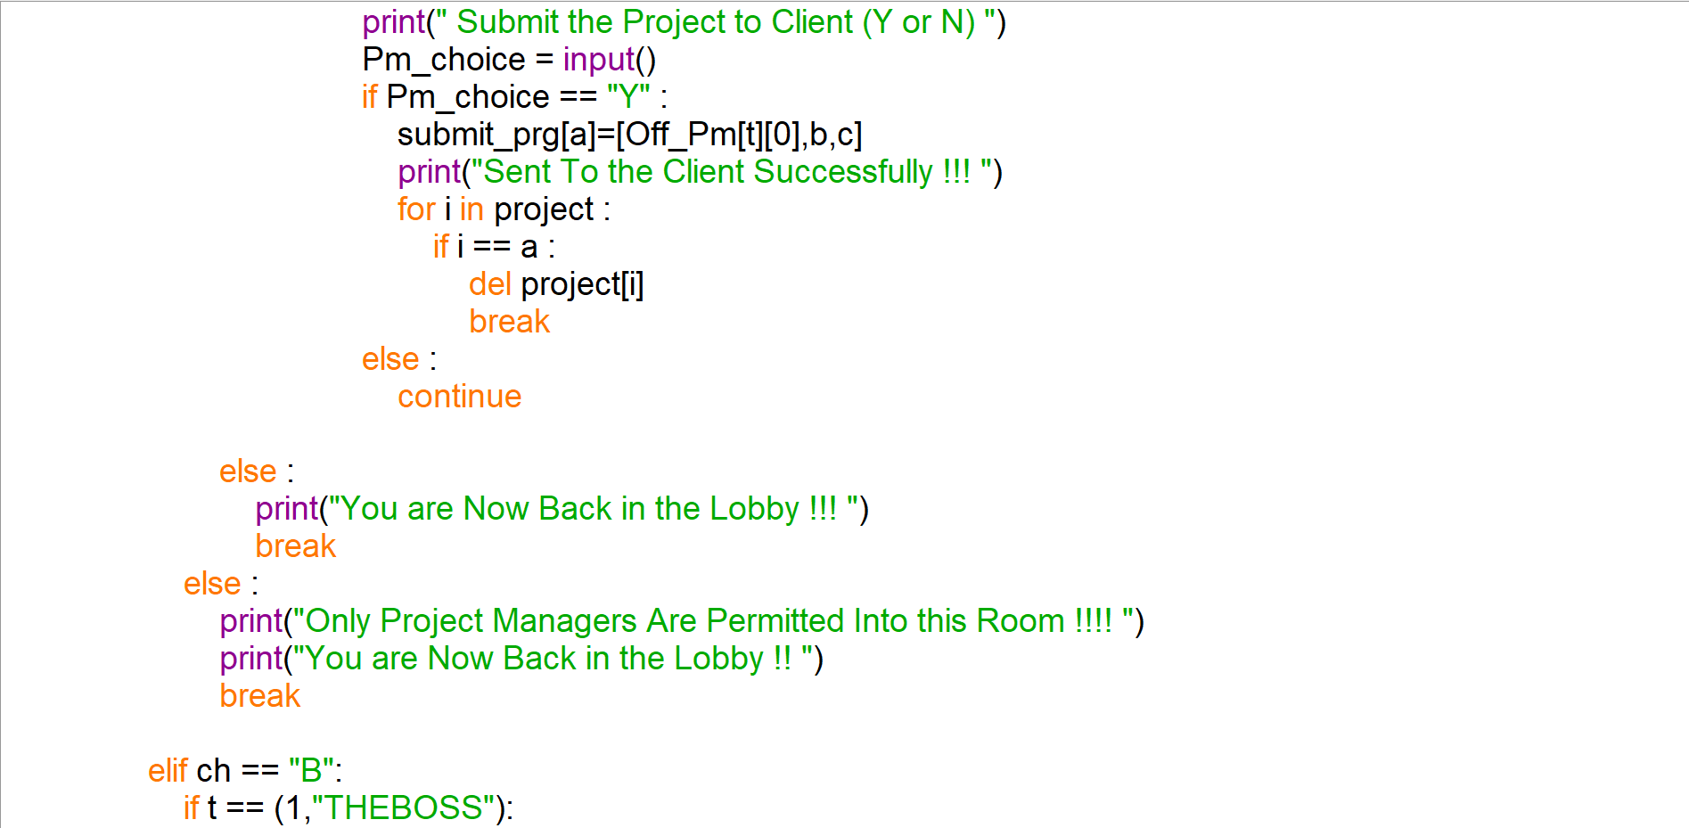

**SOURCE CODE**

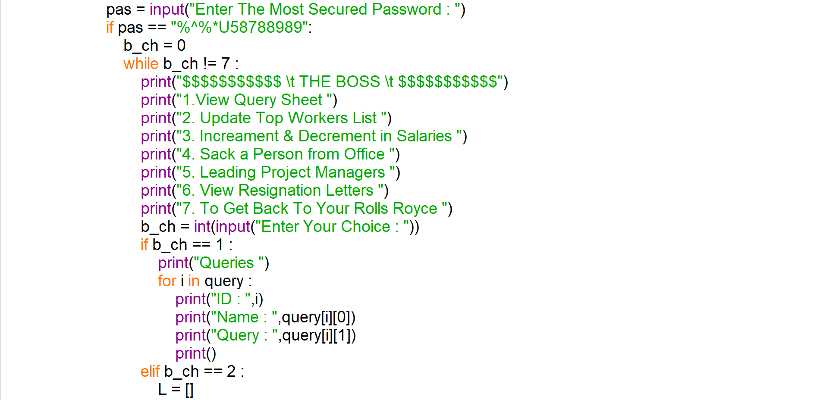

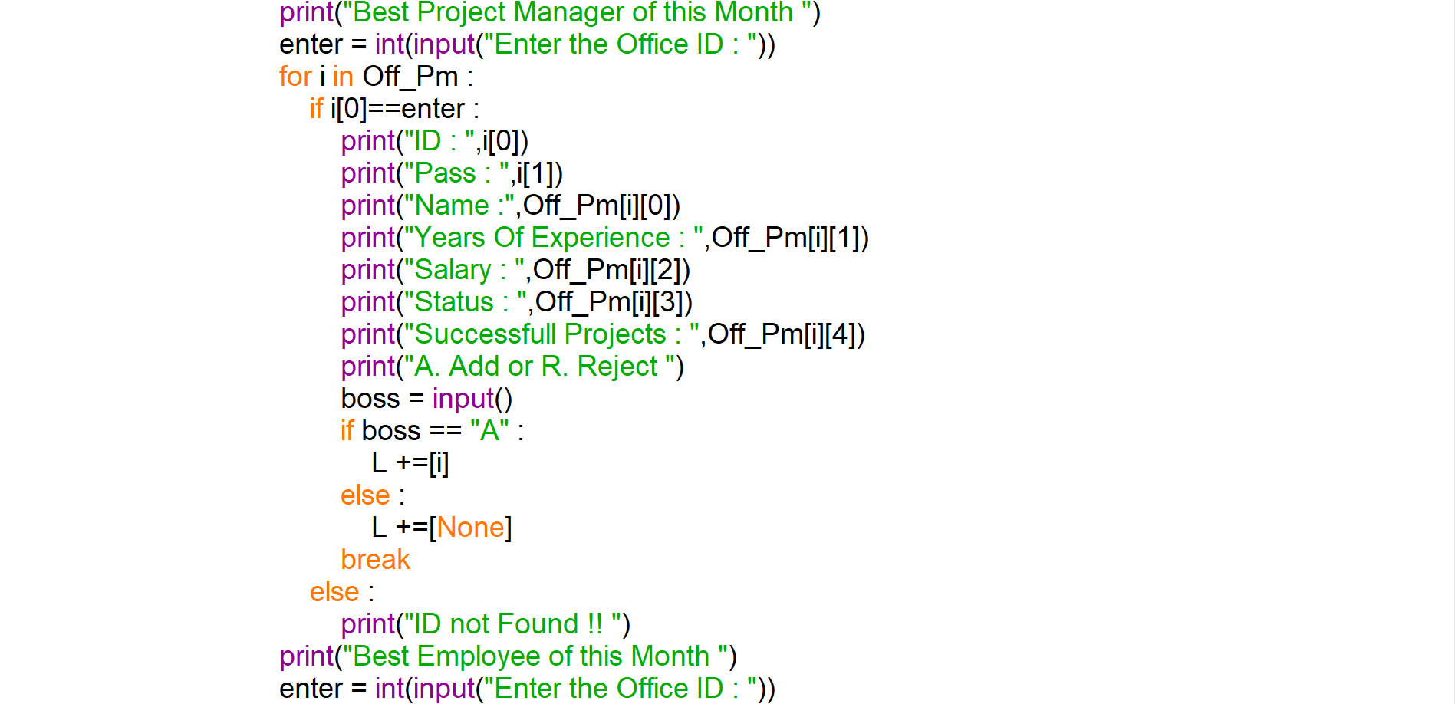

**SOURCE CODE**

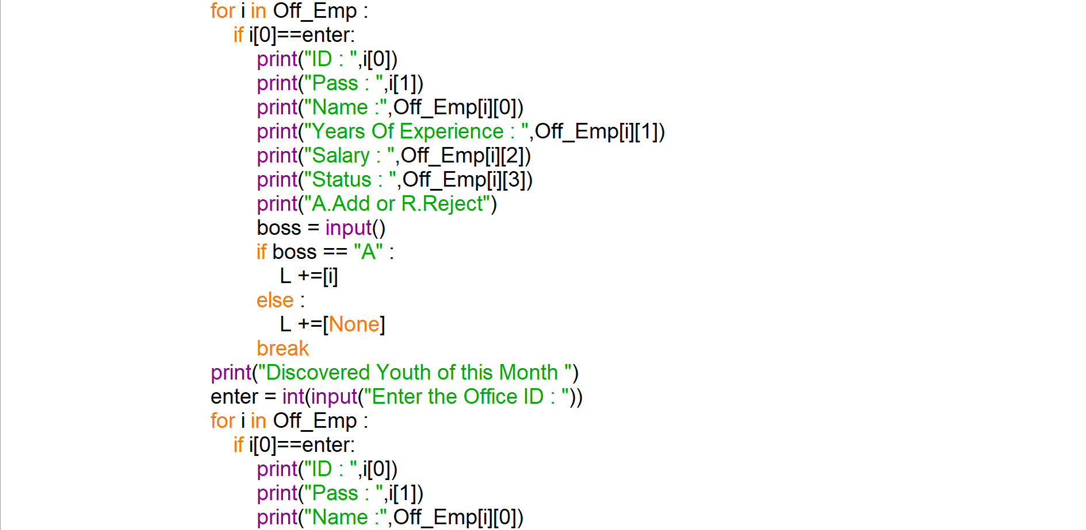

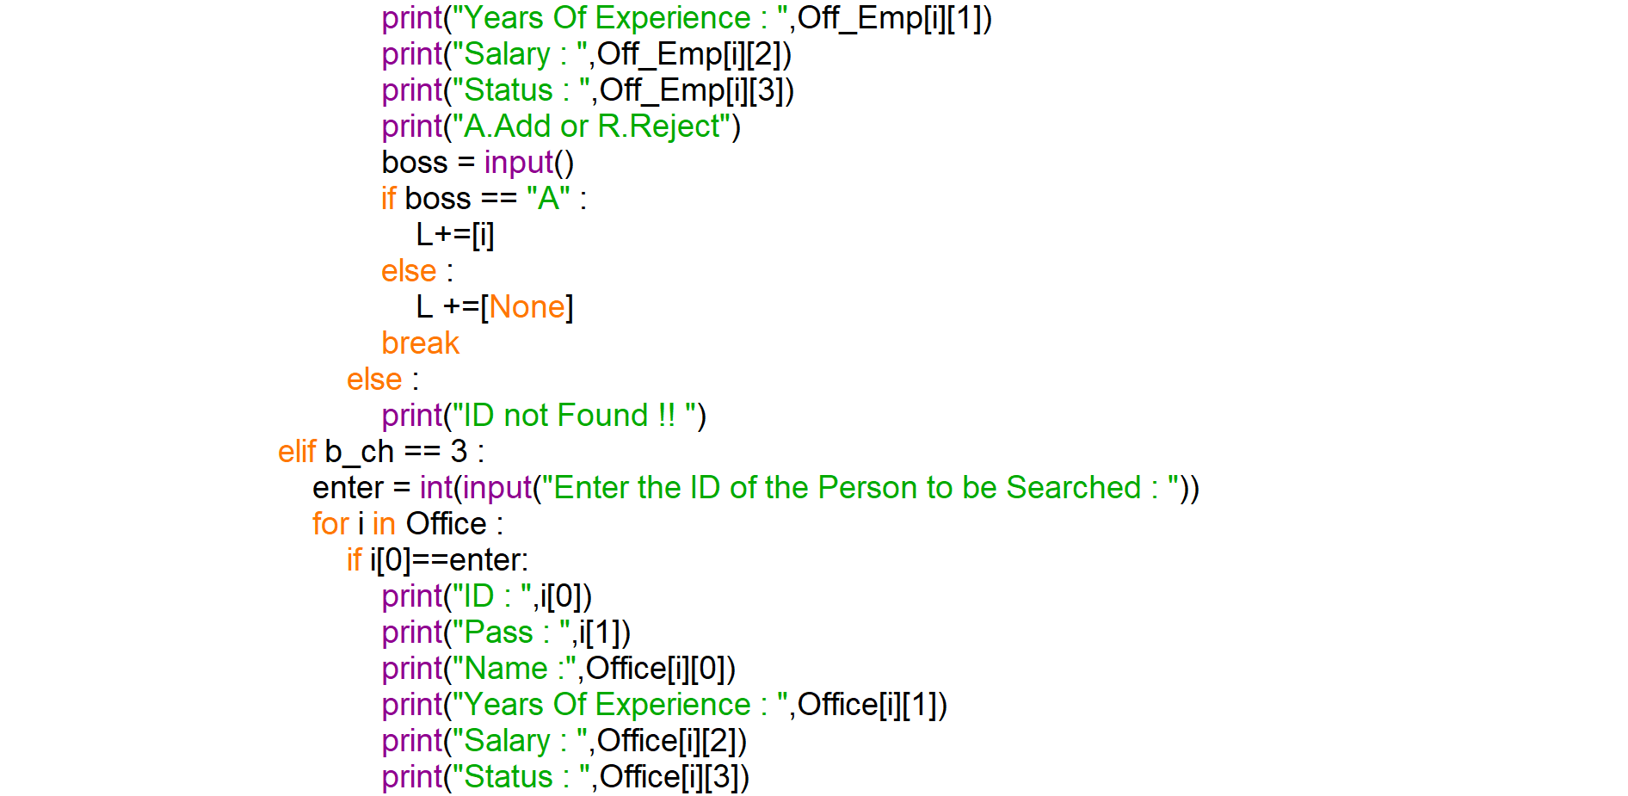

**SOURCE CODE**

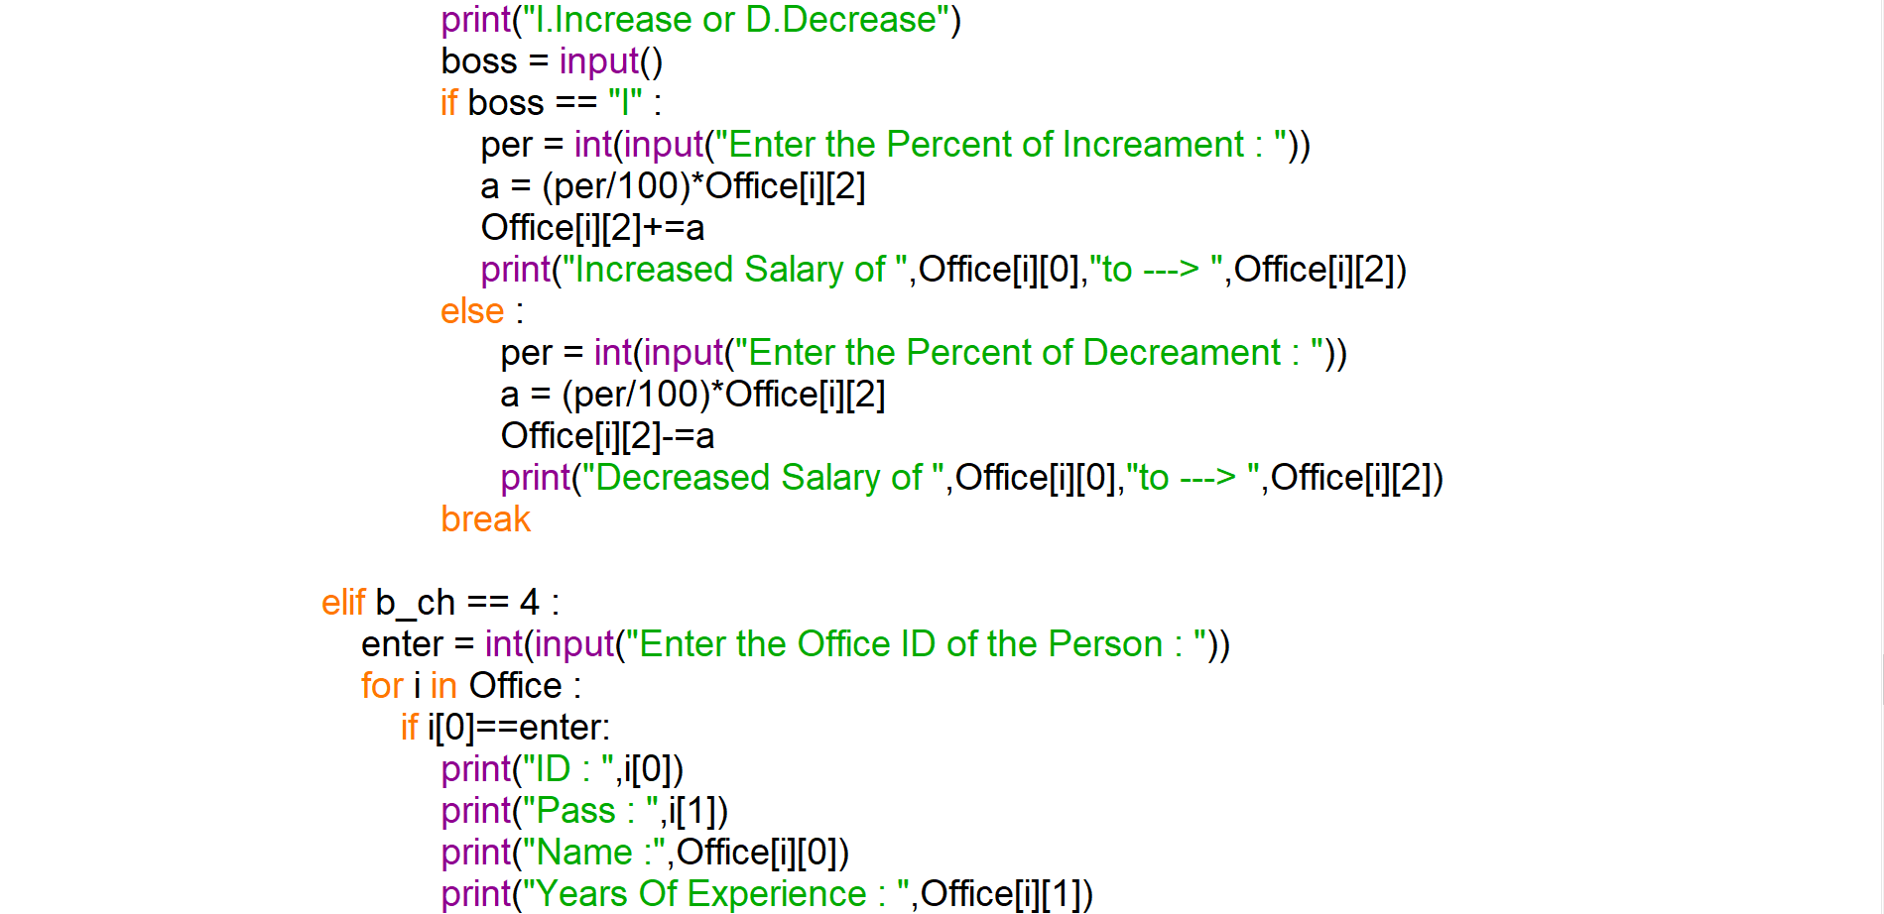

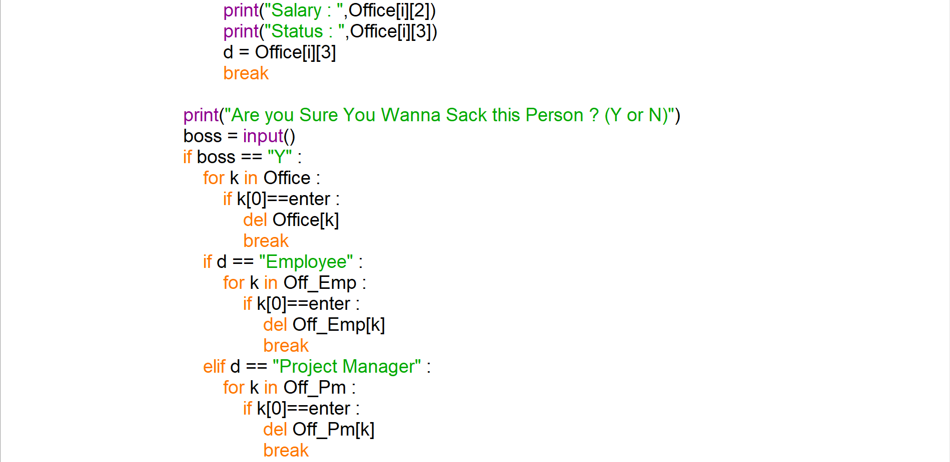

**SOURCE CODE**

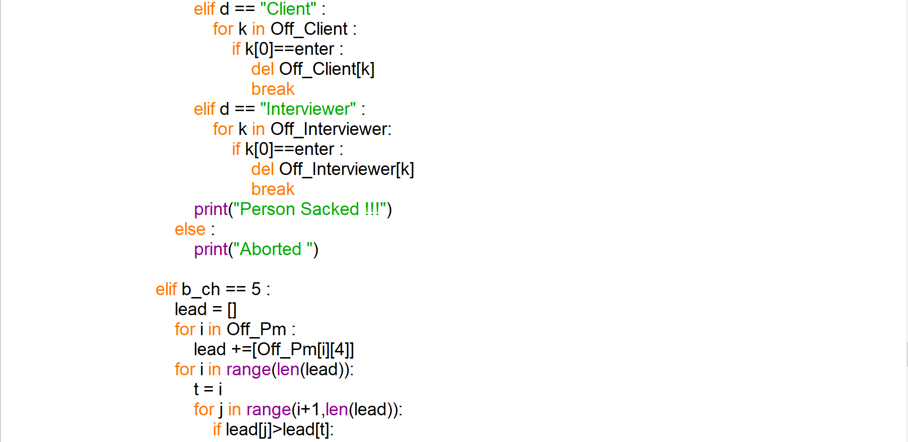

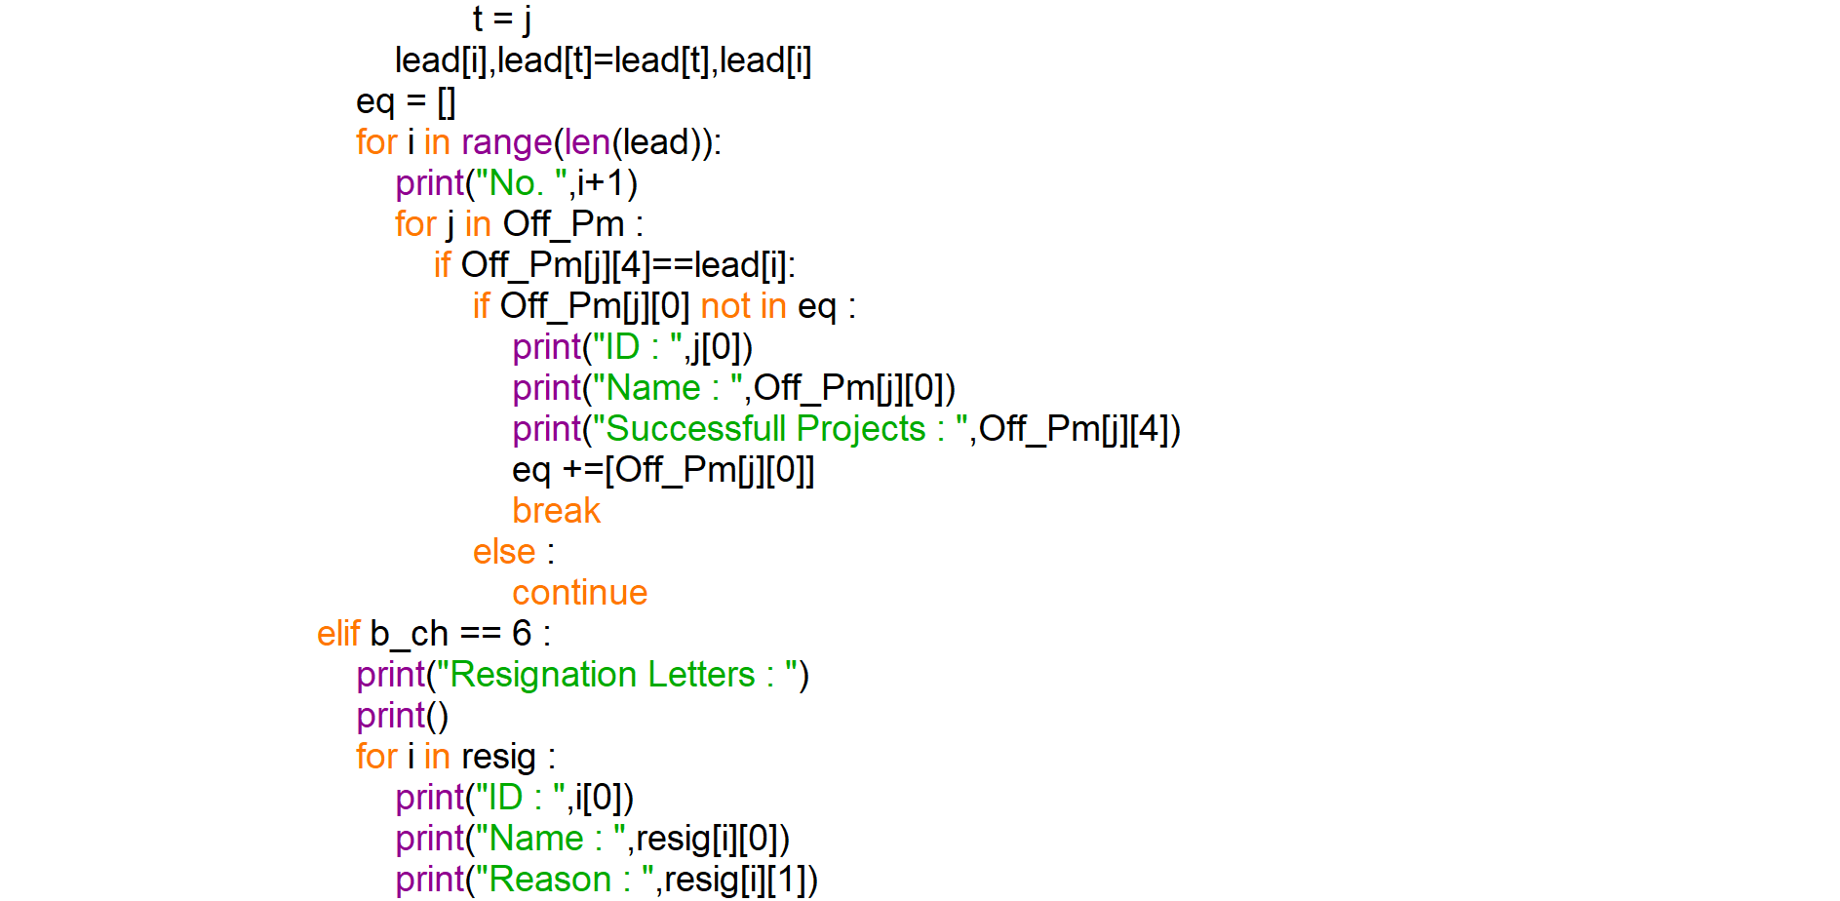

**SOURCE CODE**

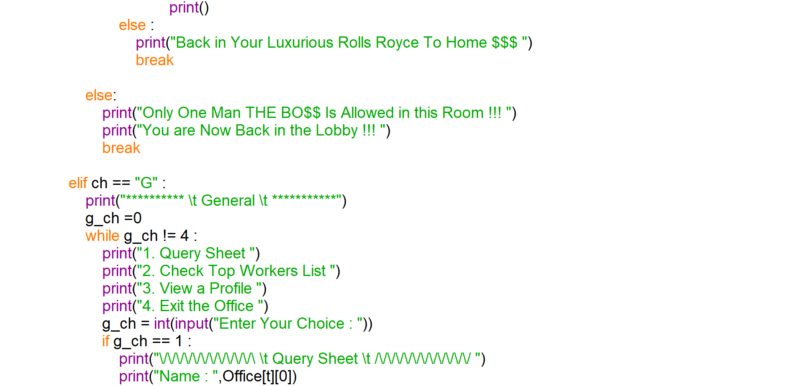

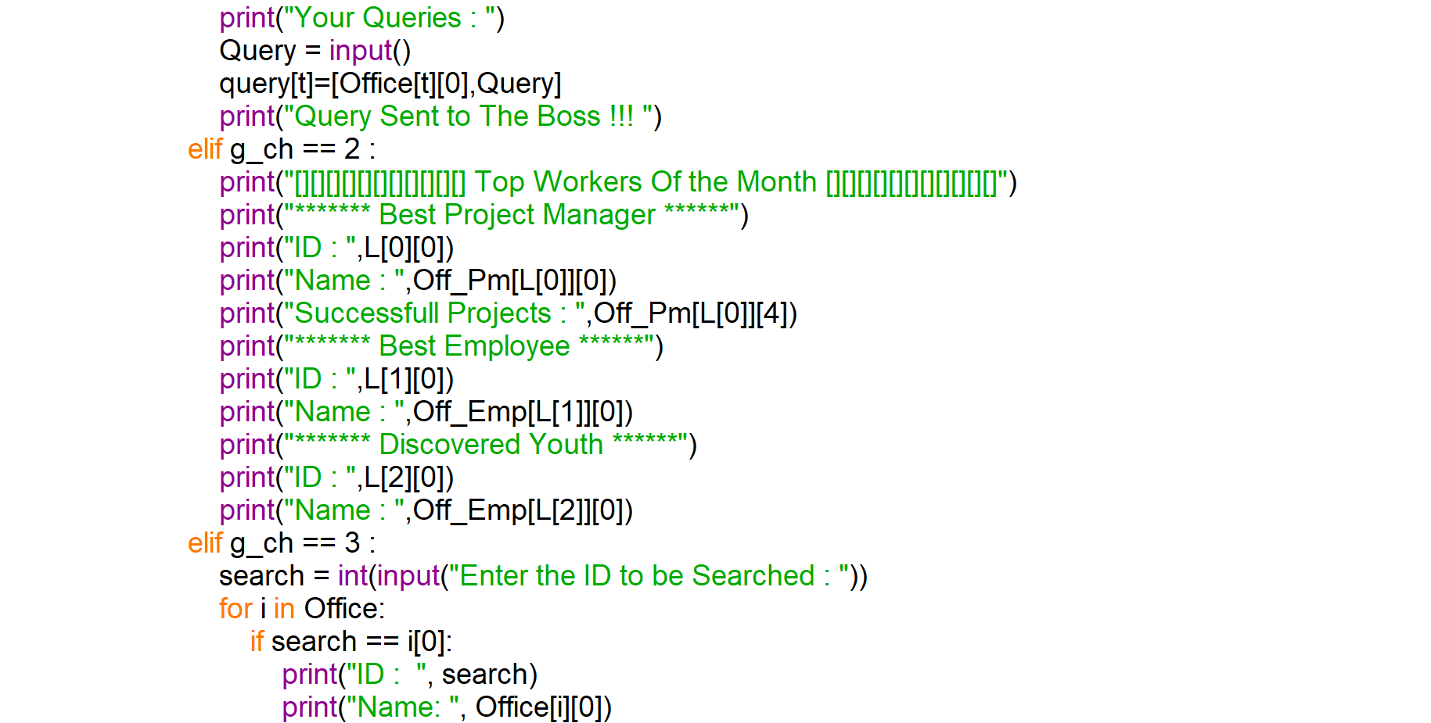

**SOURCE CODE**

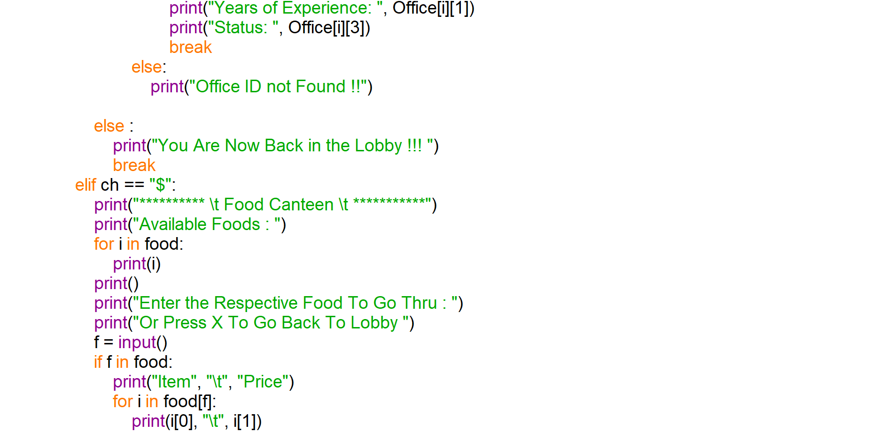

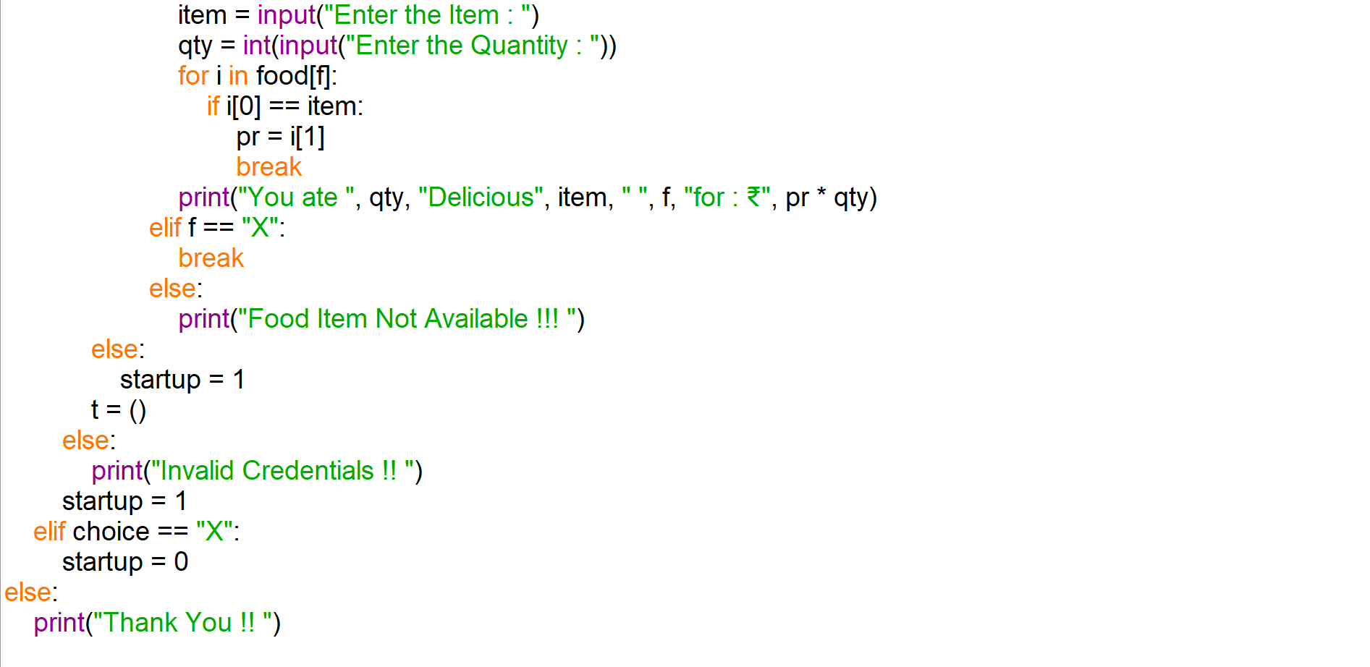

**OUTPUT**

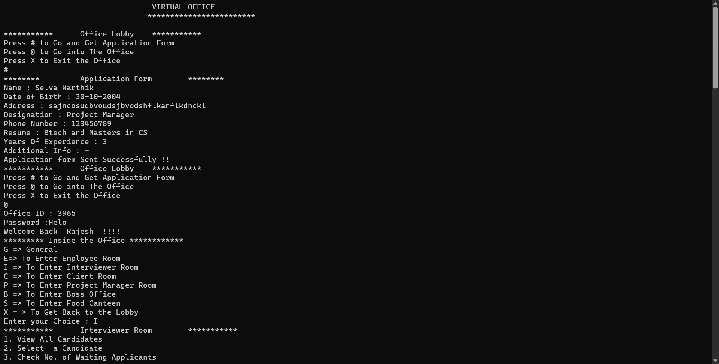 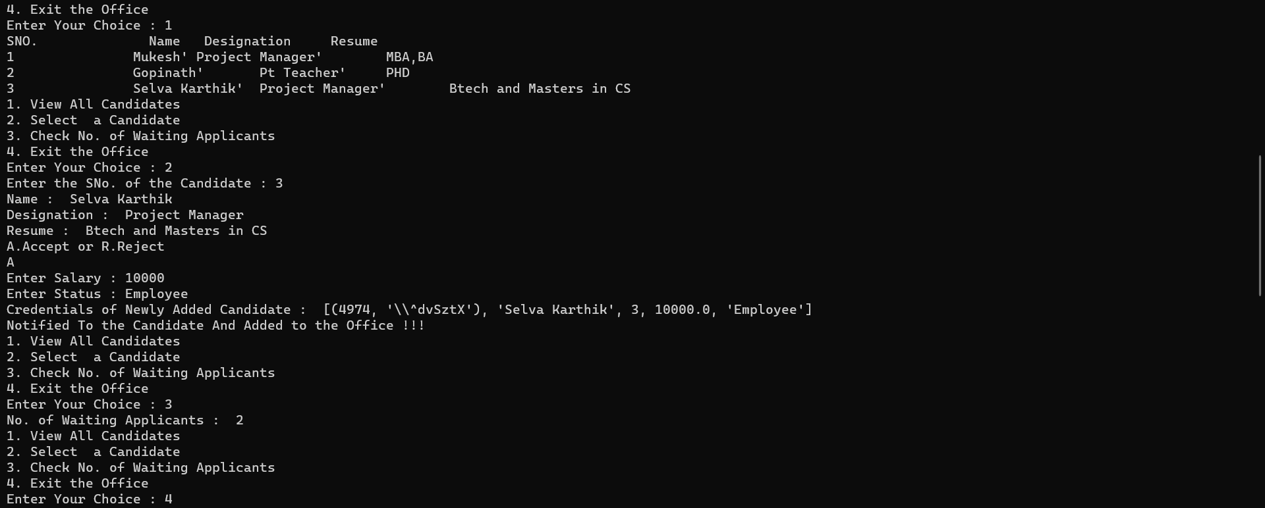

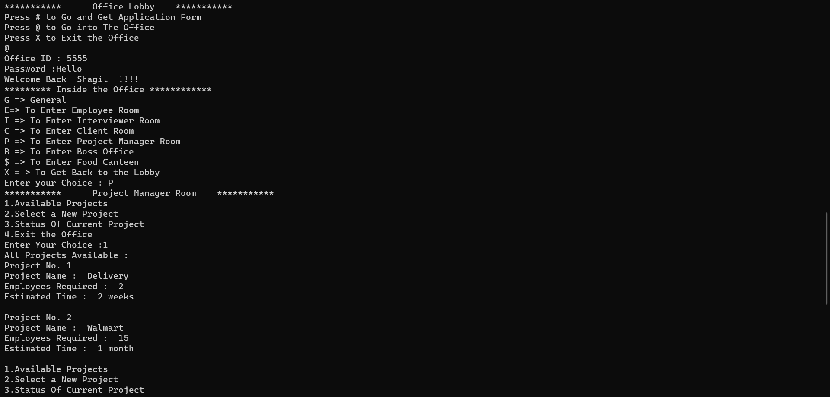 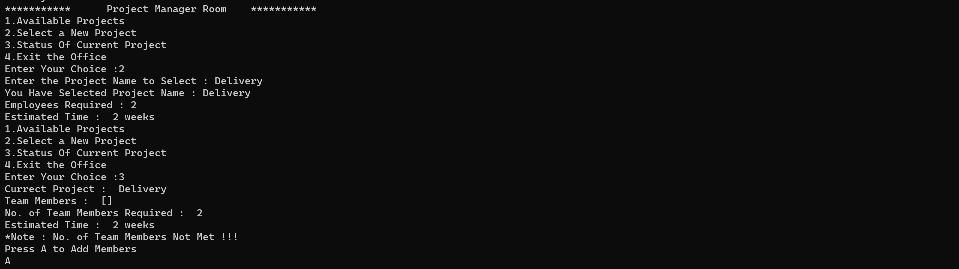 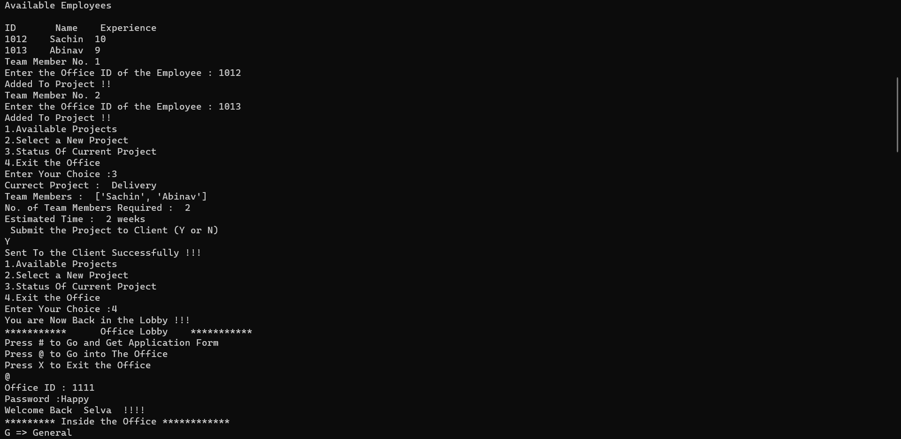

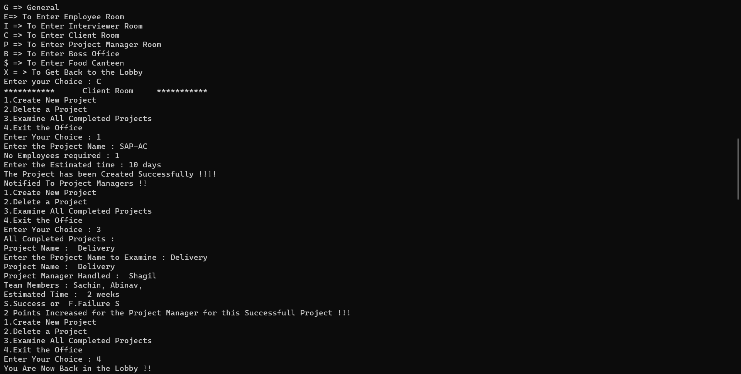 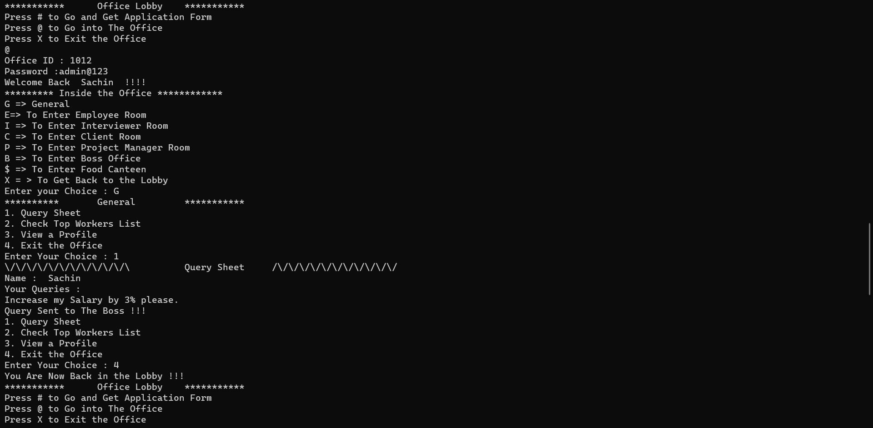 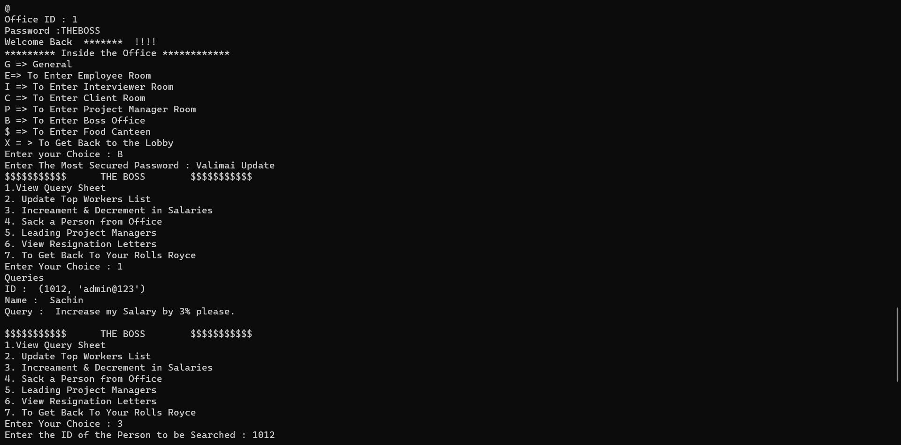 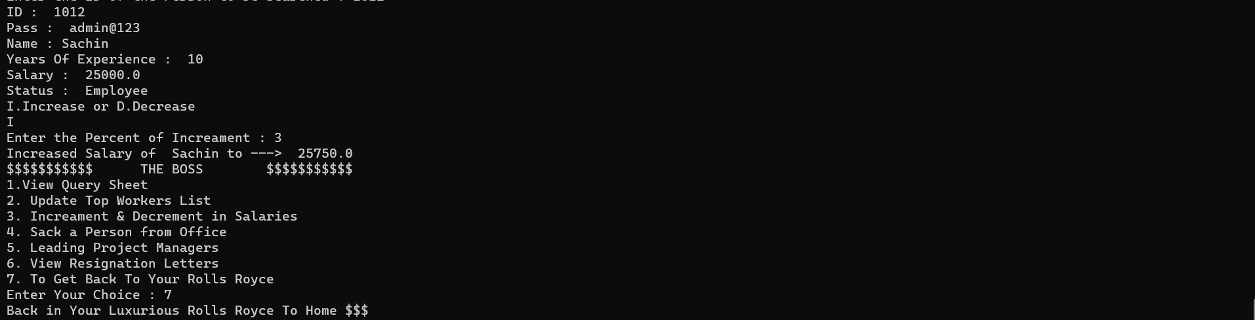

**CONCLUSION**

* This Software Performs all the Functions and Works that the Workers Inside the Office have.
* This Software is very Useful And can be used as a Virtual Office in Terms Especially During the Covid-19 Situations.
* This Software also Helps in Keeping in Track of all the Workers.





**SHORTCOMINGS AND FUTURE ENHANCEMENTS**

This Software Can be Extended to much Higher Versions by adding few elements like Including the Time the IT Consultant enters the Office and tells him the Time he can leave, adding more Roles Inside the Office, Graphics Shall be Enhanced like the Things Inside the Office to be more Realistic and many more Interesting Content Ahead.





**BIBLIOGRAPHY / WEBLIOGRAPHY**

None.